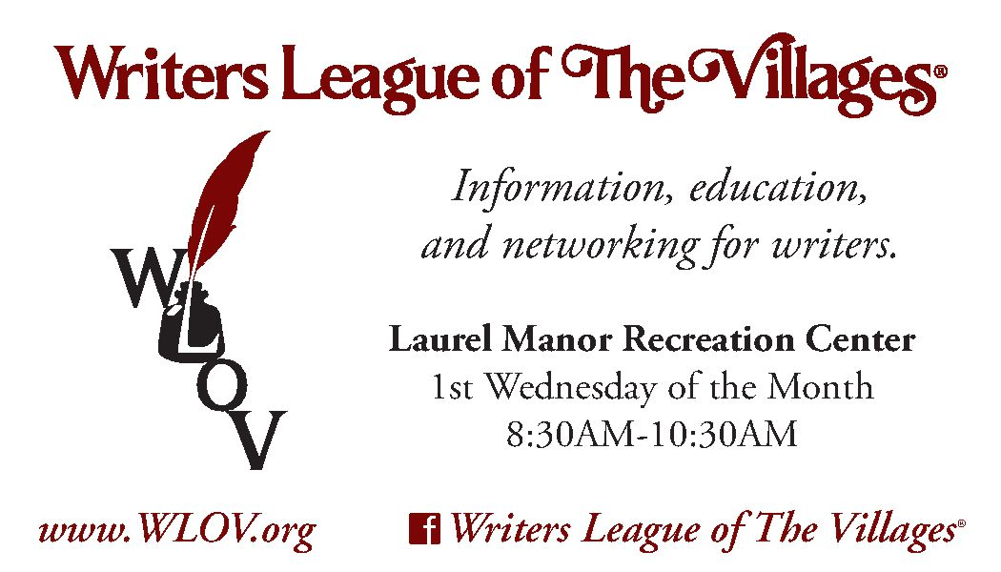

WLOV NEWSLETTER
June 1, 2017

Message From Your President

Our new WLOV business card (above) was distributed to members at the May meeting. Thanks to Diane Dean, who started this project and began working last March with The Villages Marketing Dept. to design a card with TV’s trademark logo. Diane, Rita Boehm and Jan Zahorian then met with the marketing department’s Mona de Torres to come up with a winning design.
WLOV does not have a regular business meeting in June or July. Our next meeting, August 2, will be a special “ice cream social.” It will not be Laurel Manor, but instead at Lake Miona Rec Center and in the evening. At that meeting we will vote on a new president-elect for 2017. See Calendar on page 2.
This edition of the WLOV Newsletter provides information that should interest all Villages writers. I’ve divided it into two parts. 1. INFORMATION OF SPECIAL INTEREST TO LOCAL AUTHORS, e.g., about upcoming writing events and an update on www.wlov.org. 2. INFORMATION THAT SHOULD (MIGHT) INTEREST ALL WRITERS ON THE PLANET, e.g., review of another classic ‘how-to’ writing book, the utility of fiverr.com and a new writing-related quiz.
As always, if you have ideas or information you would like to see included, please let me know.

Larry Martin
President, WLOV
drlarry437@gmail.com
Page
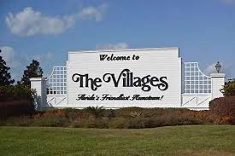
1. INFORMATION OF SPECIAL INTEREST TO LOCAL AUTHORS
Calendar of Upcoming Writing-related Events 2
Important Announcements by Mark Newhouse 3
Vic diGenti October Workshop at Laurel Manor 4
Update on www.wlov.org 5
Two New Local Book Publishers 5

- INFORMATION THAT SHOULD (MIGHT) INTEREST ALL WRITERS ON THE PLANET
Is Fiverr.com worth $5? 8
Another Classic Book on Writing 10
What a Writer Does 11
Read This – From the Internet 11
Quiz - Famous First Lines of Novels 12

PART 1. INFORMATION OF SPECIAL INTEREST TO LOCAL AUTHORS

Calendar of Upcoming Writing-related Events

DATE WLOV & Other Local FWA (www.floridawriters.net)

June 24 Focus on Marketing
All-day workshop
Hilton Orlando/Altamonte Springs
350 S. Northlake Blvd, Orlando FL 32701

July 20 Freedom to Write
Laurel Manor Rec Center
9:30 – 10:30
Coffee & Cookies

(Details on Page 3)

July 22 Focus on Conflict-Driven Stories
All-day workshop
Crown Plaza at Bell Tower Shops
13051 Bell Tower Drive, Fort Myers FL 33907

August 2 WLOV Ice Cream Social &
Limited Business Meeting
Election of new president-elect for 2017
Note Different Location & Time
Lake Miona Rec Center, 7-9 pm

(Details on Page 3)

Fri, Oct 6 Novel in a Day Workshop
With Vic DiGenti
Laurel Manor Rec Center

(Details & Registration Link on Page 4)

Thurs, Oct 19 Lessons from a Lifetime of Writing
An all-day fiction-writers workshop presented by David Morrell, author of First Blood, which was made into the Hollywood blockbuster Rambo.
Hilton Orlando/Altamonte Springs
350 S. Northlake Blvd, Orlando FL 32701

October 19-22 16th Annual Florida Writers Conference
Hilton Orlando/Altamonte Springs
350 S. Northlake Blvd, Orlando FL 32701

Important Announcements by Mark Newhouse
CALLING ALL VILLAGES WRITERS: MARK YOUR CALENDARS
VILLAGES WRITERS’ CELEBRATION OF FREEDOM TO WRITE
Thursday, JULY 20, 2017 – 9:30 – 10:30 a.m.
Laurel Manor Rec Center

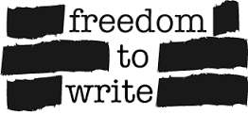
Share your love of the ‘Right to Write’ by joining us at the first ever VILLAGES CELEBRATION OF FREEDOM TO WRITE. We need every writer to come and help demonstrate the strength of The Villages’ writing community. Bring your laptop or a paper pad – doesn’t matter. Each Villager will write for 45 minutes, on ‘what the freedom to write means to me’. I will collect all the essays (either on paper or via email) and put them together in a book, for distribution to politicians, school administrators and community leaders. Let’s get the message out.
The entire event will take only one hour. Tell your writing friends and let’s unite to write. If we are successful, it will call attention to the strength and depth of our Villages writing community. Local media will be there to see our writers in action -- celebrating freedom.
WE NEED EVERY WRITER!!! WE NEED YOU! Please RSVP to mark@mark.newhouse so we know how many are coming, to be sure we have enough tables, chairs – and cookies!

PUBLICITY: THE WRITING BUG
Want publicity for your books? Have an idea for a story? I am Mark H. Newhouse, co-founder and first president of The Writers League of The Villages, and am eager to promote fellow authors in my monthly Writers Bug column for Village Neighbors Magazine. This magazine is mailed to all homes in The Villages. All ideas and authors will be considered. Email me at mark@newhouse.net or phone 352-753-3290.

Presentation at August 2nd WLOV Ice Cream Social: “I Scream Mystery”
A play by Mark Newhouse. Help solve the mystery while you enjoy your ice cream.
Lake Miona Rec Center, Wednesday, August 2nd, 7 – 9 pm.

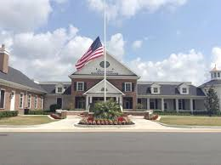
ANNOUNCING CENTRAL FLORIDA BOOK & AUTHOR EXPO FOR 2018!
We now have a date and location: January 27, 2018, again at the amazing Eisenhower Recreation Center. All authors may participate. If not a member, consider joining WLOV for first dibs on reservations and discount fee. Applications will soon be posted on www.wlov.org. This past January’s event (2017) was very successful, and next year’s should be even better. If you have ideas how to improve our Expo, send them to me, mark@newhouse.net. Remember, no idea is too crazy to be considered.
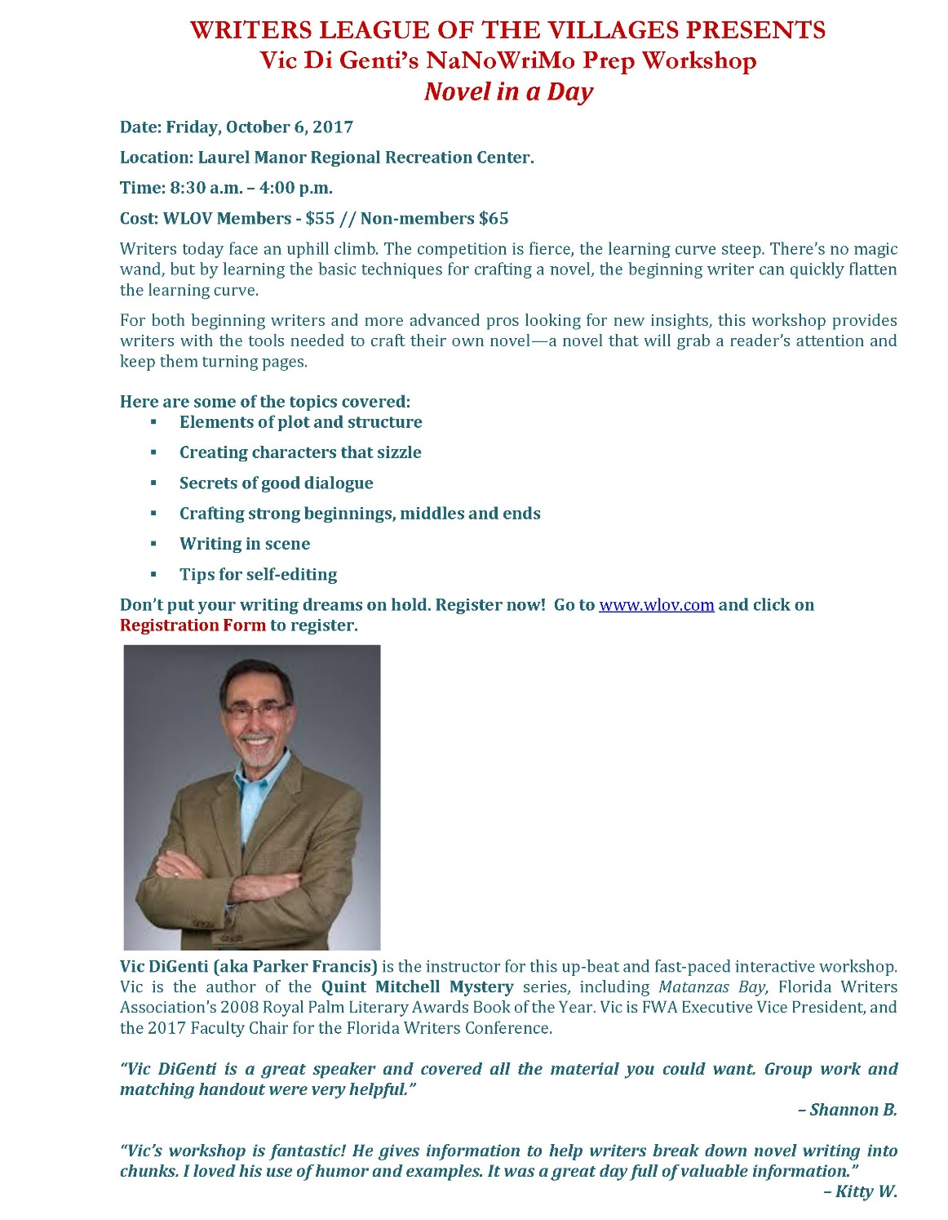

Click on Link Below for Registration Form

di_genti_registration_form_oct_6__2017.pdf

Update on www.wlov.org

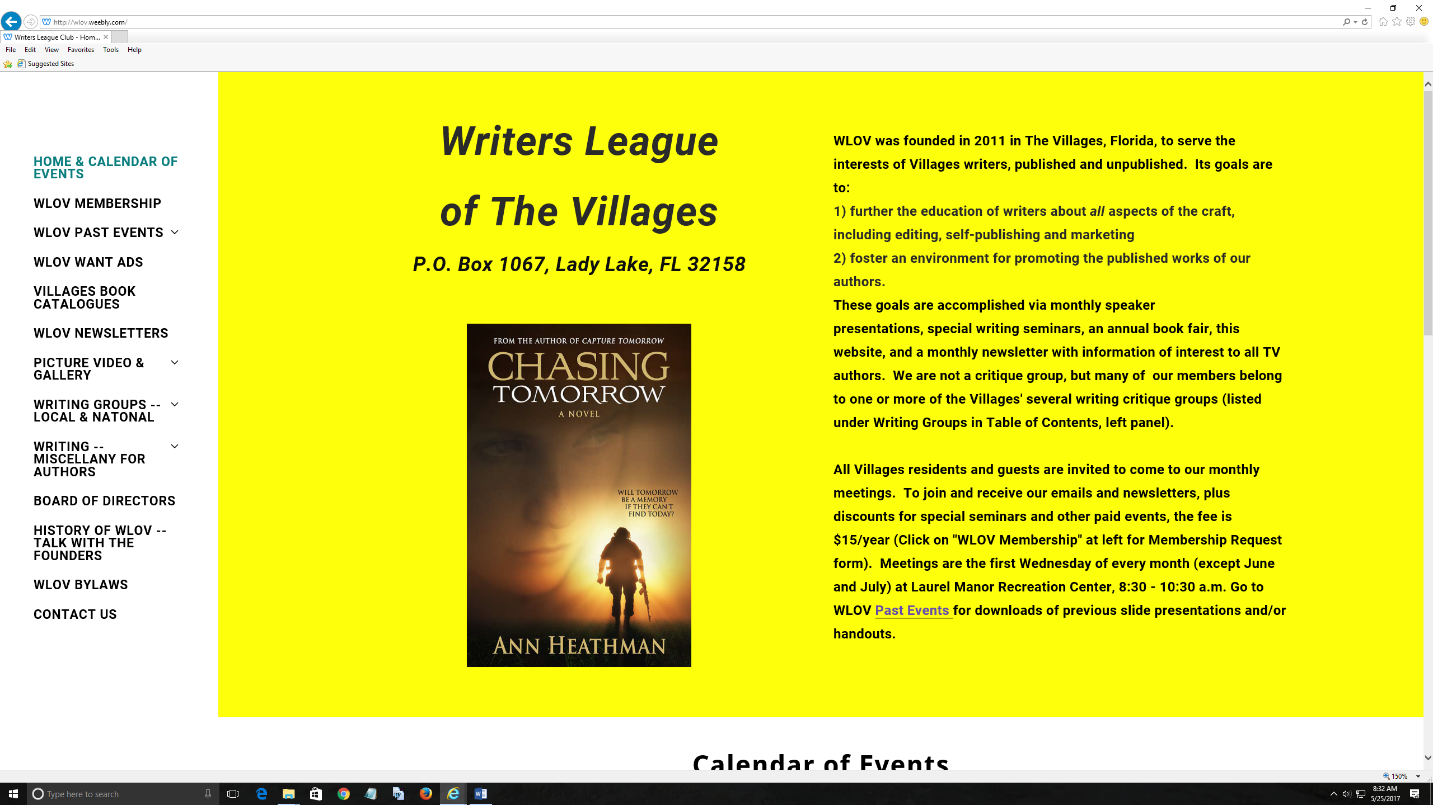

There have been more changes to www.wlov.org since the last newsletter: a new background color, and some additions to the Table of Contents. Check out the WLOV website for:
- Information on All Upcoming Events
- Past Speaker Presentations
- Newsletter Quizzes and Answers
- Writer Want Ads
- List of Writing Critique Clubs in The Villages
…And so much more

Two New Local Book Publishers
WLOV has been approached by two local book publishers who wish to connect with Villages authors.

- Sea-Hill Press (Leesburg)
- Zeta Publishing (Ocala)

Both Sea-Hill and Zeta are “full service” publishers, which means they can handle any and all services you might need for book publishing; you pay for what you want. The following information is presented for your interest only, and is not an endorsement. The owner of each company is very approachable, and will be happy to answer your questions.
Sea-Hill Press, P.O. Box 490521, Leesburg, FL 34749|
Owner and President: Greg Sharp., Phone (805) 845-8636 or (877) 397-0005, email greg@seahillpress.com
Website: http://www.seahillpress.com/

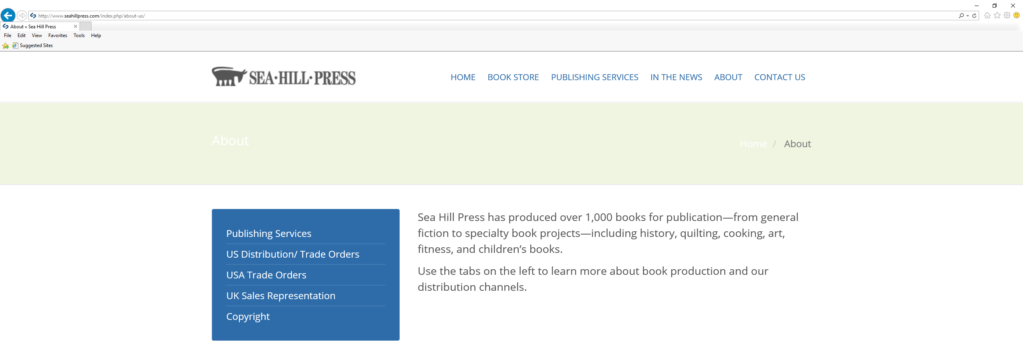

Owner Greg Sharp sent us the following information about his company.

“At Sea Hill Press we help our customers navigate the path toward successfully publishing their books, whether wanting three copies or three thousand. Our editors and designers are trained and experienced specialists in the book industry. Since 1999, we have been the go-to people to make sense of the steps involved in publishing. We are here to help establish realistic publishing goals and to assist in achieving them. Sea Hill Press provides various levels of service, whether you need some editorial assistance or a complete publishing solution. Customers will soon be able to visit us at our new location in downtown Leesburg, Florida, or we are happy to come visit by appointment.”

Zeta Publishing, 3850 SE 58th Ave. Ocala, FL 34480
Owner and Chief Operating Officer: Winsdell Langdale, phone 352-694-2553, email
wins@zetapublishing.com
Website: https://zetapublishing.com/

PART 2.
INFORMATION THAT SHOULD (MIGHT) INTEREST ALL WRITERS ON THE PLANET

Is Fiverr.com worth $5?
By Larry Martin

What is Fiverr.com?
Fiverr.com is a popular website where you can connect with people who offer a variety of services over the internet, most starting at just $5 (hence “fiverr”). I have used it to find help with Word formatting, proofreading, beta reading, some simple art work, and for social media promotion. The range of services offered is enormous. Generally, if something can be done over the internet, you’ll find it offered. Each person offering the services is graded by users, and as expected most people who pop up tend to have high scores. Here is a screen shot from their home page.

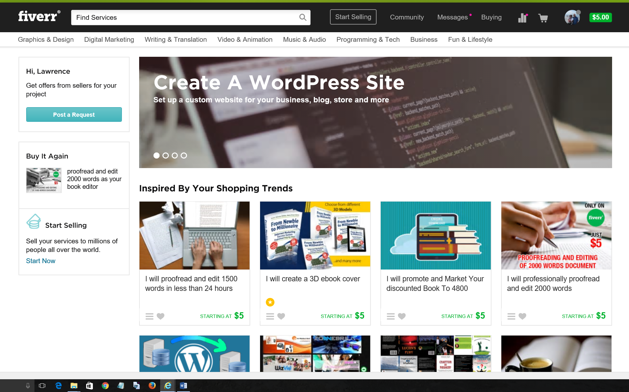

What is the average price for the service?
There is no average, only a minimum: $5. People offering services will do some minimal amount of work for just $5. For example, they will edit your work or do proofreading at $5 for the first 2000 words – a fairly common offer. So you have little to lose if you find their initial work sub-par. If you like the sample work, then you can negotiate the full price for whatever you want, e.g., to edit or proofread a 70K-word novel.

Some jobs don’t lend themselves to partial work, such as formatting an e-book or designing a book cover. In those situations you need to do more research on offers made. You can ask questions via the web site and message the service provider until you make up your mind.

How do you pay?
By credit card or via Paypal. I use Paypal, which is incredibly easy which you’ve set up an account. Paypal links to your credit card, but once you’ve set it up, you never have to enter the credit card data again.

What is the quality?
VARIABLE. I have ordered work through Fiverr.com about 15 times over the past few years. I estimate 1/3 was very good, 1/3 was so-so and 1/3 was terrible. The most money I wasted – payment made for work that was simply not acceptable – was @$30; this was for proofreading part of a novel. The service provider wanted to rewrite many sections, and her rewriting was awful. Obviously, I sent her no more pages. On the other hand, I had a couple of $5-10 jobs that were terrific, and really got me out of a jam with Word formatting.

Do I recommend Fiverr.com?
Yes, with reservations. The advantages are 1) you can wade in cheaply, hoping to find just the right person before you spend more; 2) the results are generally quick, within a few days; 3) it obviates individual web searches for every service you might need; 4) payment is easy. The disadvantages: 1) some of the people just aren’t competent for the service they offer; 2) You only know these service providers by their “handles” and not by real names, location, etc.

On balance, if you’re looking for help with a well-defined task – formatting, proofing, editing, social media publicity – try Fiverr.com but start slowly. Check out the comments about the people who are offering the service, and don’t hesitate to ask questions. Begin with a small amount of money, $5-15. If the initial service works out, you can then contract for more.

***

Classic Books on Writing (continued)
By Larry Martin

In previous editions of the newsletter I discussed Stephen King’s On Writing, and Strunk & White’s Elements of Style. Here’s another classic of this genre: On Writing Well.
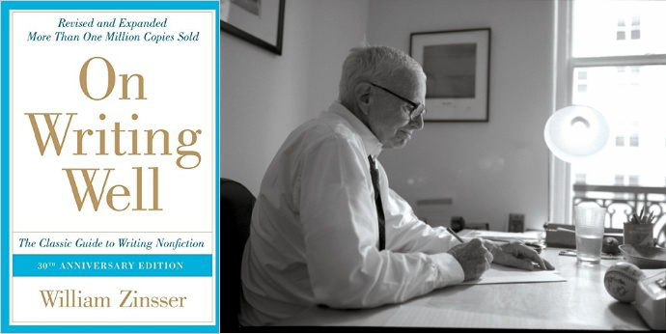
William Zinsser died at age 92, in 2015. He first published On Writing Well in 1976. The book, aimed at non-fiction writers, has been updated often and has sold over 1.5 million copies. Zinsser stresses “simplicity and efficiency, but also style and enthusiasm.” Here are 10 of his many tips for improving your non-fiction writing. Obviously some of these tips pertain to fiction as well.

1. Don’t make lazy word choices: “You’ll never make your mark as a writer unless you develop a respect for words and a curiosity about their shades of meaning that is almost obsessive. The English language is rich in strong and supple words. Take the time to root around and find the ones you want.”
2. On the other hand, avoid jargon and big words: “Clear thinking becomes clear writing; one can’t exist without the other. It’s impossible for a muddy thinker to write good English.”
3. Writing is hard work: “A clear sentence is no accident. Very few sentences come out right the first time, or even the third time. Remember this in moments of despair. If you find that writing is hard, it’s because it is hard.”
4. Write in the first person: “Writing is an intimate transaction between two people, conducted on paper, and it will go well to the extent that it retains its humanity.”
5. And the more you keep in first person and true to yourself, the sooner you will find your style: “Sell yourself, and your subject will exert its own appeal. Believe in your own identity and your own opinions. Writing is an act of ego, and you might as well admit it.
6. Don’t ask who your audience is…you are the audience: “You are writing primarily to please yourself, and if you go about it with enjoyment you will also entertain the readers who are worth writing for.”
7. Study the masters but also your contemporaries: “Writing is learned by imitation. If anyone asked me how I learned to write, I’d say I learned by reading the men and women who were doing the kind of writing I wanted to do and trying to figure out how they did it.”
8. Yes, the thesaurus is your friend: “The Thesaurus is to the writer what a rhyming dictionary is to the songwriter–a reminder of all the choices–and you should use it with gratitude. If, having found the scalawag and the scapegrace, you want to know how they differ, then go to the dictionary.”
9. Read everything you write out loud for rhythm and sound: “Good writers of prose must be part poet, always listening to what they write.”
10. And don’t ever believe you are going to write anything definitive: “Decide what corner of your subject you’re going to bite off, and be content to cover it well and stop.”
What a Writer Does
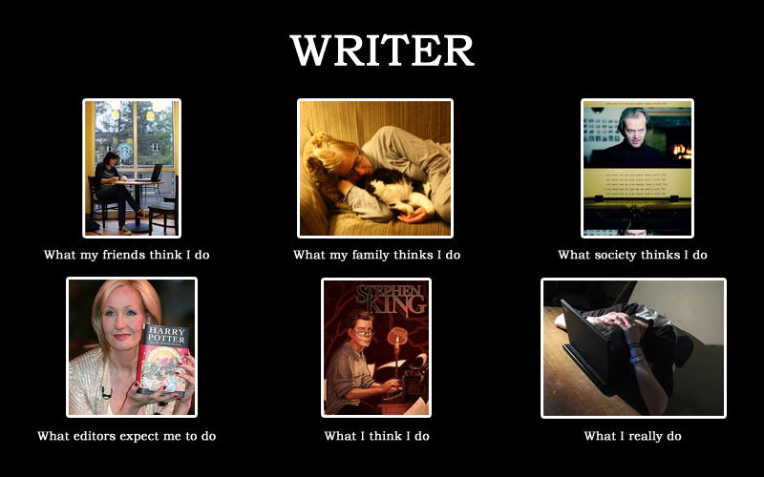
Go to http://perceptionvsfact.com/ and enter “writer” for more iterations on this theme.
***

Read This
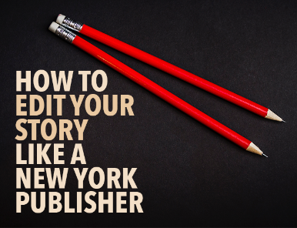
There are a gazillion internet postings aimed at writers, offering advice on every aspect of the craft. Two WLOV Board Members recently came across an item they recommend. The links are provided here. Thanks to Millard Johnson for “New York Publisher” and Rita Boehm for “Discoverability-Amazon.com.”
http://thewritepractice.com/how-to-edit-your-story/
http://hometownauthors.com/everything-else/discoverability-learning-how-to-optimize-amazon-ads/

Quiz – Famous First Lines of Novels
By Larry Martin

Each issue of the newsletter has a writing-related quiz. This one asks you to name the source of these 21 famous first lines of novels. Some are readily apparent, while others are not so obvious. To make it a little more difficult, you are asked to connect the quote with the author in the list provided, not the book. Also, the author list contains 4 extra names unrelated to any of these first lines. The answers, posted on www.wlov.org under Writing – Miscellany for Authors, will provide both author and book title.

Famous First Lines

Call me Ishmael. Some years ago – never mind how long precisely – having little or no money in my purse, and nothing particular to interest me on shore, I thought I would sail about a little and see the watery part of the world.

It is a truth universally acknowledged, that a single man in possession of a good fortune, must be in want of a wife.
Happy families are all alike; every unhappy family is unhappy in its own way.
It was a bright cold day in April, and the clocks were striking thirteen.

All children, except one, grow up.
All this happened, more or less.

We were somewhere around Barstow on the edge of the desert when the drugs began to take hold.
It was the best of times, it was the worst of times, it was the age of wisdom, it was the age of foolishness, it was the epoch of belief, it was the epoch of incredulity, it was the season of Light, it was the season of Darkness, it was the spring of hope, it was the winter of despair.
In my younger and more vulnerable years my father gave me some advice that I’ve been turning over in my mind ever since.
“Whenever you feel like criticizing any one,” he told me, “just remember that all the people in this world haven’t had the advantages that you’ve had.”
Someone must have slandered Josef K., for one morning, without having done anything truly wrong, he was arrested.
If you really want to hear about it, the first thing you'll probably want to know is where I was born, and what my lousy childhood was like, and how my parents were occupied and all before they had me, and all that David Copperfield kind of crap, but I don't feel like going into it, if you want to know the truth.
Stately, plump Buck Mulligan came from the stairhead, bearing a bowl of lather on which a mirror and a razor lay crossed.
The sky above the port was the color of television, tuned to a dead channel.

Famous First Lines of Novels (continued)
They shoot the white girl first.
It was love at first sight.
It was a queer, sultry summer, the summer they electrocuted the Rosenbergs, and I didn't know what I was doing in New York.
In the late summer of that year we lived in a house in a village that looked across the river and the plain to the mountains.
The cold passed reluctantly from the earth, and the retiring fogs revealed an army stretched out on the hills, resting.
It was a dark and stormy night; the rain fell in torrents, except at occasional intervals, when it was checked by a violent gust of wind which swept up the streets (for it is in London that our scene lies), rattling along the house-tops, and fiercely agitating the scanty flame of the lamps that struggled against the darkness.
Mother died today.
Mrs. Dalloway said she would buy the flowers herself.
List of Authors (in alphabetical order)
Isaac Asimov
Jane Austen
J. M. Barrie
Pearl Buck
Edward George Bulwer-Lytton
Albert Camus
Stephen Crane
Charles Dickens
F. Scott Fitzgerald
William Gibson
Joseph Heller
Ernest Hemingway
James Joyce
Franz Kafka
Herman Melville
Toni Morrison
Vladimir Nabokov
George Orwell
Sylvia Plath
J.D. Salinger
Hunter S. Thompson
Leo Tolstoy
Mark Twain
Kurt Vonnegut
Virginia Woolf

