**Books by WLOV Members Published in 2016-2018**

Prepared by Larry Martin

Authors are listed in alphabetical order, for books they published during years 2016-2018. F = fiction, NF = non-fiction. For primary audience, C = children, YA = young adult, A = adult. To get to Amazon for any book, simply click on the link. (If that doesn’t work, hover over the hyperlink with your mouse or trackpad pointer, then right click and select “Open Weblink in Browser.”) If you are a WLOV member and have recently published a book not listed here, and wish it included, please send me the information (drlarry437@gmail.com). Include a high resolution cover photo, a short blurb about the book, and the Amazon link where the book can be purchased.

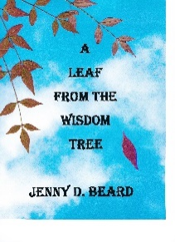**Jenny D. Beard (Donna Beard), *A Leaf From the Wisdom Tree*** **(F, A)**

<https://www.amazon.com/Leaf-Wisdom-Tree-Jenny-Beard/dp/1537660489/>

A continuation of Jenny D. Beard’s saga, *Higher Up The Mountain*, in that elderly Edith Balmer regales her guests about mysterious deaths and steamy sex that took place in the early 1900’s. Before beginning her story, Edith relates the cloak and dagger life of her young neighbor, pretty Debbie Van Buren, who has come into possession of a satchel during a one-night affair. The heavy satchel causes Debbie to watch her back at all times.

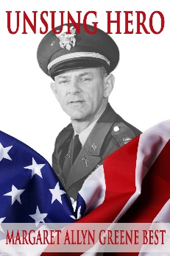

**Peggy Best, *Unsung Hero* (NF, A)**

[**https://www.amazon.com/Unsung-Hero-Margaret-Allyn-Greene/dp/1483479080/**](https://www.amazon.com/Unsung-Hero-Margaret-Allyn-Greene/dp/1483479080/)

This book is a tribute to all service members who have supported support our country throughout our history. It is the story of one man, Major Albert V. Greene, who was a prisoner of war during WWII, and later served in Korea and Vietnam. His life story, couched in the backdrop of American and world history, invokes the spirit of patriotism, duty, and honor all unsung heroes display.

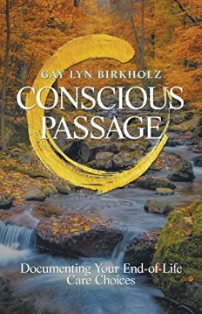<https://www.amazon.com/Conscious-Passage-Documenting-End-Life-ebook/dp/B07C2JJTGN/>

No one wants to have to second-guess how a loved one wants to be cared for at the end of his or her life, but that hasn’t stopped some families from being torn apart by that very question. Gay Lyn Birkholz, a former professor of medical and business ethics who has served on several ethics boards coaching patients and their families through end-of-life ethical dilemmas, examines why it’s so important to make your wishes known in this self-help guide. Learn how to: take ownership of end-of-life choices; talk about this topic with family and loved ones; document your care choices and intentions; and give your health care representative a full picture of your wishes. She also tackles the complicated question of the financial burdens that come with end-of-life care, because ending up in a hospital (especially if it involves aggressive treatment) can mean exorbitant expenses. These are your choices, and you have a right for them to be honored. Claim your say, and die on your terms with the guidance in Conscious Passage

**David Bishop, *Love & Other Four-Letter Words* (F, A)**

<https://www.amazon.com/Other-Four-letter-Words-novelette-Bishop-ebook/dp/B0767C7VB7/>

### This novelette lets the reader decide whether this is the story of:

-a perfect murder,

-or a botched attempted murder,

-or simply a death by accident.

The Kile/Bishop collaboration came in response to numerous emails from readers asking: If Matt Kile writes fiction when he isn’t working as an investigator, why aren’t there any stories written by Matt? Being the writer who developed the character of Matt Kile, I got to decide what Matt writes as well as his writing style. Some Kile/Bishop stories will be mysteries, others will better be described as American drama or simply stories about the people who inhabit the mean streets.

**David Bishop, *Scandalous Behavior* (F, A)**

<https://www.amazon.com/gp/product/B077RSHYZ9/>

Written by fictional detective Matt Kile, in collaboration with his creator, master mystery writer David Bishop. This novelette tells the story of a regular, hardworking, salt-of-the-earth guy. He pays his bills, loves his mother, and lives by the rules. Then he meets Mary and everything changes. Scandalous Behavior is a mystery and a story of American Drama. The second in the collaboration of Matt Kile and David Bishop. Enjoy.

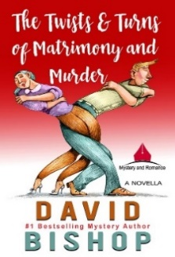**David Bishop, *The Twists & Turns of Matrimony and Murder* (F, A)**

<https://www.amazon.com/Twists-Turns-Matrimony-Murder-ebook/dp/B077Y5L88W/>

## The Twists & Turns of Matrimony and Murder sets somewhere between the stories of Prince Charming and War of the Roses. Constance Merriweather remembered the part of her wedding vows about for better or for worse. During and after the ceremony she smiled and played kissy-face while steeling herself for the expected worse. Frank Merriweather thought he was getting the better, but soon learned he was mistaken. The two of them settled in to co-exist in their matrimonial forest. Then came the murder. Everyone knew who was dead, but no one knew for certain who was supposed to be dead. And, of course, who committed the murder was complicated by whether the actual victim was the intended victim.

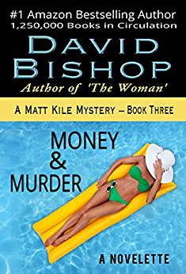**David Bishop, Money and Murder (F A)**

One of the stories in my Matt Kile Mystery Series. <https://www.amazon.com/Money-Murder-Novelette-Matt-Mystery-ebook/dp/B00A2B8QIA/>

P.Q. Winston Rutledge is the richest man in Copper City, Arizona, and he believes someone will soon try to kill him. The story quickly deteriorates into murder, and the ambitions of relatives in pursuit of his fortune. PQ’s family is a collection of oddballs with a common bloodline. Fascinating people you’d love to have at your next dinner party, but each comes with their own set of secrets and entanglements. PQ is survived by a widow, the same age as his daughter, and two sons, one of whom—well, you’ll have to read the story. You won’t be sorry you did.

**David Bishop, *The Year We Had Murder* (F, A)**

<https://www.amazon.com/Year-Murder-Matt-Kile-Mystery-ebook/dp/B071LP7FHZ/>

The Year We Had Murder is book seven in the Matt Kile Mystery Series. The novel is a frisky, sometimes over-the-top, romp through Hollywood, a town with its own manner, imagery, and code of conduct. Matt finds himself smack dab in the middle of the craziness when he’s invited to a Hollywood party where nothing is as it seems. The party is at the home of a famous film producer, who’s married to the big screen’s current sex symbol. Matt takes his favorite date, Clarice Talmadge, to the gathering of silicone starlets and movie moguls.

**Christie Seiler Boecke, Murder 101 (F, A)**

<https://www.amazon.com/Murder-101-Christie-Seiler-Boeke-ebook/dp/B076DK5LCY/>

Mount Alexander, Georgia earned it's reputation because of the outstanding college located there. That is until one of it's professors, lurking in the shadows, watched and waited for the right moment, the right victim. Wanted to take the lives of certain coeds attending the college. The first kill was straight forward and effortless. the second even simpler. As the murderer continued to kill, there was no shame, no regret. Detectives Carter Holden and Riley Anne West are assigned to investigate the deaths of the coeds attending the college. A harrowing journey begins as they become consumed with finding who and why a professor is murdering the young women, students of the college. A body is found and another, as the nightmare continues. The two detectives race to find the cause of the terror overshadowing the college. There are few places to hide and numerous places to die as the killer's rage grows.

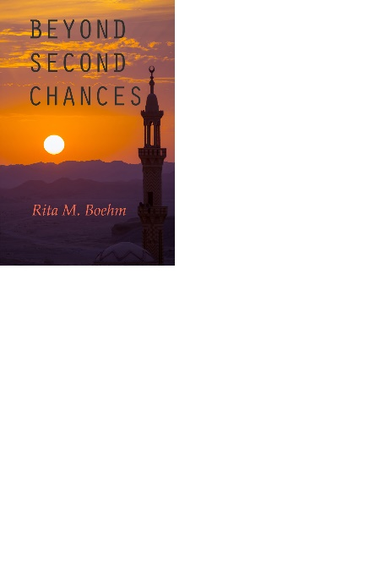

**Rita Boehm, *Beyond Second Chances* (F, A)**

<https://www.amazon.com/Beyond-Second-Chances-Rita-Boehm/dp/1537686348>

In this exciting sequel to Second Chances, Lindsay Talbot is faced with a difficult choice: travel to a poverty-stricken, terrorist-filled, Arab country to save the life of the man she loves, or leave his future to chance. She makes her choice and pays the price. However, as Lindsay recuperates from a violent assault much closer to home, she is confronted with a devastating betrayal - and faces an uncertain future.

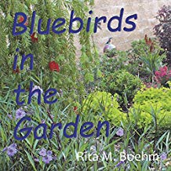

**Rita Boehm, *Bluebirds in the Garden* (NF, C)**

<https://www.amazon.com/Bluebirds-Garden-Rita-M-Boehm/dp/1720520186/>

Colorful photographs present young children with a charming story about a family of bluebirds nesting in a backyard garden.

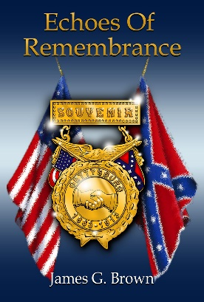

**James G. Brown, Echoes of Remembrance (F, A)**

<https://www.amazon.com/Echoes-Remembrance-Novel-Gettysburg-Reunion/dp/0692059334/>

Memories can be wonderful celebrations or terrible realities. Over 50,000 veterans, from North and South, gathered at Gettysburg, PA in July 1913. The Great 50th Anniversary Reunion of the Civil War battle was a singular event. For the old soldiers of the Grand Army of the Republic and the United Confederate Veterans, it was a time to rekindle old memories. But for Jimmy Valentine, of the 149th New York Volunteer Infantry, the memories are ones he would rather not revisit. He still lives with the pain of lost friends and a shattered romance that brought him to the army. His journey back to Gettysburg reopens memories of those terrible three days in July, 1863. The memories have aroused his hatred of the Rebels and his own guilt for what transpired. Can he resolve unfinished business? Or will the memories hold him captive forever?

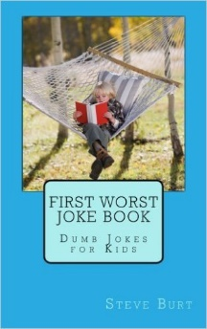**Steve Burt, *Dumb Jokes for Kids series (First, Second, Third, and Fourth Worst Joke Book)* (NF, C)**

<https://www.amazon.com/s/ref=nb_sb_noss?url=search-alias%3Daps&field-keywords=Dumb+Jokes+for+Kids%2C+Burt&rh=i%3Aaps%2Ck%3ADumb+Jokes+for+Kids%5Cc+Burt>

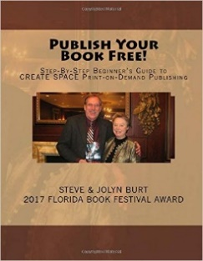

**Steve and Jolyn Burt, *Publish Your Book Free: Step-By-Step Beginner's Guide to CREATE SPACE Print-on-Demand Publishing* (NF, A)**

<https://www.amazon.com/Publish-Step-Step-Print-Demand/dp/1537495712/>

2017 Florida Book Festival Award silver Best How-to and 2017 New England Book Festival Award bronze Best How-to



**Steve Burt,** ***Christmas Soup for the Soul: 10 Hearty Helpings from New England's Christmas Story Pastor* (NF, C)**

<https://www.amazon.com/Christmas-Soup-Soul-Helpings-Englands/dp/1539337510/>

2017 Florida Book Festival Award for Best Holiday Book

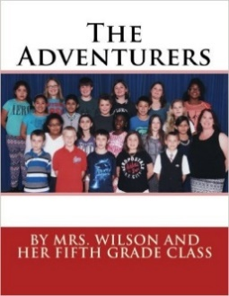

**Jolyn Joslin-Burt and Kristin Wilson, *The Adventurers* (NF, C, YA, A)**

[https://www.amazon.com/Adventurers-Wilson-Fifth-Grade-Class/dp/1530954886/](https://www.amazon.com/Adventurers-Wilson-Fifth-Grade-Class/dp/1530954886/%20%20ref=sr_1_1?ie=UTF8&qid=1486835816&sr=8-1&keywords=the+adventurers%2C+mrs.+wilson%27s+Fifth+Grade+Class)

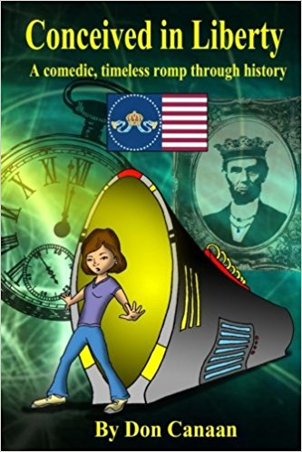**Don Canaan, *Conceived in Liberty: A comedic timeless romp through history* (F, A)**

[**https://www.amazon.com/Conceived-Liberty-time-traveling-American-Timeless-ebook/dp/B01KAX8QY8/**](https://www.amazon.com/Conceived-Liberty-time-traveling-American-Timeless-ebook/dp/B01KAX8QY8/)

As Britain tries to regain its 13 colonies, time travel with us through the American monarchy founded by Benedict Arnold. The United Kingdom and Benedict Arnold, with the assistance of his British masters, transformed into the Union of Royal American States after defeating George Washington at Yorktown. "Conceived in Liberty," is a comedic, sci-fi, time-traveling romp through history by award-winning journalist Don Canaan.

[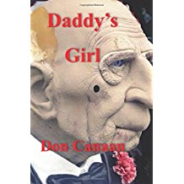](https://www.amazon.com/Daddys-Girl-prequel-Roberts-Mystery/dp/1536962287/ref=sr_1_3?ie=UTF8&qid=1490400549&sr=8-3&keywords=pretty+little+girl+canaan)**Don Canaan, *Daddy’s Girl* (F, A)**

[**https://www.amazon.com/Daddys-Girl-prequel-Roberts-Mystery/dp/1536962287/**](https://www.amazon.com/Daddys-Girl-prequel-Roberts-Mystery/dp/1536962287/)

Studies have confirmed that molested children often become molesters themselves. *Daddy's Girl*, a horror novella based on a true “ripped from the headlines” story, serves as a prequel to *Pretty Little Girl*, a psychological thriller in which a female detective searches for a molested daughter who, in a concerted attempt to regain her identity, abandons her now-demented father.

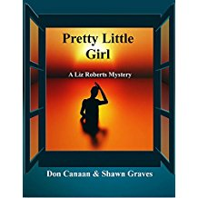**Don Canaan and Shawn Graves. *Pretty Little Girl* (F, A)**

[**https://www.amazon.com/Pretty-Little-Girl-Roberts-Mystery-ebook/dp/B006C4A5Y4/**](https://www.amazon.com/Pretty-Little-Girl-Roberts-Mystery-ebook/dp/B006C4A5Y4/)

The e-book version of *Pretty Little Girl*, published in 2014, is now available free for Kindle, Nook, Kobo, Smashwords and from the iTunes store.

**Don Canaan, *Spaced-Out: Baby’s Final LSD Trip* (F, A)**

<https://www.amazon.com/Spaced-Out-Babys-Final-LSD-Trip-ebook/dp/B07CF6YTHZ/> You don’t have to be Jewish to empathize with “Baby,” a 10-year-old boy who, salivating over a comic book containing titillating panels of Wonder Woman’s breasts, learns his GI father has been killed during a World War 2 battle. This shocking news, as well as learning about the Nazi extermination of Six Million Jews, converts the now-adult Baby’s quest for comfort into a path resulting in alcohol, LSD and murder. However, his drug-induced euphoria continues to haunt this search for love. Wherever he goes realistic visions of Nazis constantly follow him. Judith, an editor of a singles dating magazine, rescues Baby from the streets of New York City, nurturing him in an attempt to unlock his fantasies and return him to reality. But by doing so, Baby’s paranoia and guilt are accentuated.

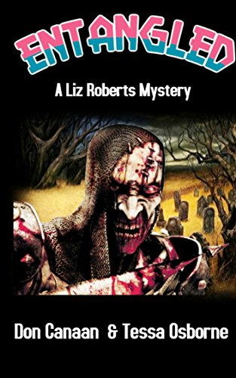

**Don Canaan and Tessa Osborn, *Entangled: A Liz Roberts Mystery (*F, A)**

<https://www.amazon.com/dp/B07F17TSDK/>

*Entangled*, a stand-alone novella, concludes the series of “Daddy’s Girl,” “Pretty Little Girl” and “The Baby Thief.” *Entangled*, the final battle between good and evil, will reveal answers to questions raised in the earlier books. It is e-book, print and audiobook formats, as well as in Portuguese and Spanish versions.

**Donald Howard (Don Canaan), *Tijuana Bibles* (NF, A)**

<https://www.amazon.fr/Tijuana-Bibles-American-Phenomenom-English-ebook/dp/B079K7H2B5>

These small eight-page books of comic strips depicting popular cartoon characters, actors, politicians and athletes as lewd or obscene parodies of themselves first appeared in the United States during the 1920s, and were sold into the 1960s. These booklets were widely popular and were known by a variety of names including “Tillie and Mac books,” “blusies,” and “blue bibles.” However, we know them today as “Tijuana Bibles” or “eight-pagers.”

**Don Canaan (Editor), *Israel News Faxx Index 1994-2017* (Kindle, NF, A)**

<https://www.amazon.com/Israel-News-Faxx-1994-2017-ebook/dp/B07B6F22RS/>

Hyperlinked index to Israel News Faxx, 1994-2017. The stories encompass the history of Israel, the Palestinian Authority as well as Jews around the world. The 2018 index will appear early next year

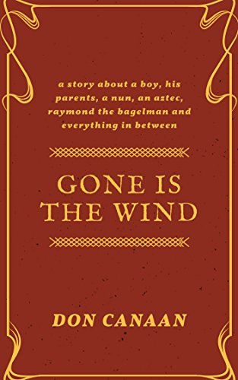

**Don Canaan, *Gone is the Wind* (Kindle, F, A)**

<https://www.amazon.com/Gone-Wind-Don-Canaan-ebook/dp/B079HDHCLQ/>

The adventures of a pre-teen boy who encounters a mysterious, satanic-type, bagel-pretzel vendor on the street adjacent to the City College of New York. Raymond, as he is known to students that included General Colin Powell, entices the child to retrieve a balloon attached to a bagel. If he successfully completes this mission, the child and his family would be awarded a year's supply of free bagels. But the mission is harder than it seems and the child is sent back into time.

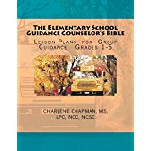**Charlene Chapman, *The Elementary School Guidance Counselor's Bible* (NF, A)**

**https://www.amazon.com/Elementary-School-Guidance-Counselors-Bible/dp/1523879068/**

45 group guidance plans for grades 1-5 on relevant topics: Study Skills, Drug Free, Home Alone, Bully Free School, Respect Yourself & Others, Healthy Eating, Good Touch/Bad Touch and more.



**Linda J. Chapman & Mary Lois Sanders, *Freddie & Stumper, Best Friends Forever* (F, C)**

https://www.amazon.com/Freddie-Stumper-Best-Friends-Forever/dp/1532872488/

Freddie and Stumper, a young bullfrog, are best buddies and love having adventures in the Georgia swamp near Freddie’s house. But when Freddie’s parents tell him they are moving to Florida to a new job and a new home, Freddie doesn’t want to go. What will he do without Stumper to talk to?



**Paul Garneau Clark, *Big Birds in The Villages, Florida: A Villager's Guide* (NF, A)**

<https://www.amazon.com/gp/product/1725025663/>

This field guide provides photographs and descriptions of larger birds in The Villages, Florida. Intentionally regional confined, the guide points-out simple uniquely identifying characteristics that differentiate one bird from another.

**Lindsay Collier, *The Funniest Book You Will Ever Read. Period!* (NF, A)**

<https://www.amazon.com/Funniest-Book-Read-Period-Fullest-ebook/dp/B074CN2242/>

I laughed my whole way through the writing of this book. If you have as much fun reading it as I had writing it, you are in for a real treat. Have a blast reading it, laugh your ever-loving butt off, and share it with your friends - and maybe even your enemies (who will then become your friends). Keep on smiling and be someone else’s reason to smile each day.

**Lindsay Collier, *Fifty Shades of Growing Old (NF, A)***

<https://www.amazon.com/Fifty-Shades-Growing-Old-Fullest-ebook/dp/B07H6PMHL3/>

'Fifty Shades of Growing Old' is really all about 'Growing Young' in your second fifty years. Lindsay Collier's popular "Growing Young Site' blog has been a great source of creative ideas on how to stay young for those in their second fifty years for several years, and this book contains some of the best articles from this site. Some say that growing old is like being on an airplane during a storm - once you're aboard there is nothing you can do about it. Don't believe that one bit - these books will prove this theory is wrong! Lindsay was formerly one of the foremost creative thinking experts in the US and has now focused his skills on ideas to help people add zest to their lives. The ideas are useful for anyone but are spot on for seniors. Every senior needs this book! The book can be read cover to cover or just opened to a random page for a thought or two to really make your day. Articles are short and to the point, often quite funny and entertaining, challenging, and always a bit different. You should have a copy of this book in your den or office, bedroom, bathroom, garage, car, basement, tool shed etc. This is a part of Lindsay Collier's "Live Your Life To the Fullest' series which includes 5 other books that take a creative look at topics ranging from how to add humor to your life, how to live happily ever after, retirement, and surviving loss. Please enjoy!

**Marian Davenport, *God’s Desire is You* (NF, A)**

<https://www.amazon.com/Gods-Desire-You-revelation-prophetic-ebook/dp/B07C772D6T/>

God’s Desire is You is a revelation of the prophetic words found in the Song of Solomon. Through Solomon song God prophetically revealed the story of his love for mankind throughout human history. Written as a devotional, personal experience, dreams, and visions reveal supernatural encounters that stretch us with the possibilities of knowing God intimately.

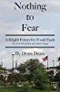**Donn Dears, *Nothing to Fear* (NF, A)**

<http://amzn.to/1miBhXy>

An engineer’s view of why CO2 emissions are nothing to fear, why renewables create unnecessary problems, and an explanation of why the sun is a major player in global warming.

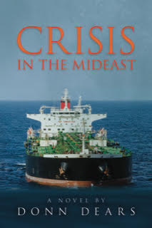 **Donn Dears, *Crisis in the Middle East* (F, A)**

<http://amzn.to/2Ga3PNU>

Crisis in the Mideast tells the story of the dangers and intrigue associated with Iran’s cutting off one-fifth of the world’s oil supply. Internal conflicts within the administration confuse America’s response, while Iran’s actions are the result of schisms within the Iranian government.

Restoring the flow of Saudi Arabia’s oil is crucial to resolving the crisis.

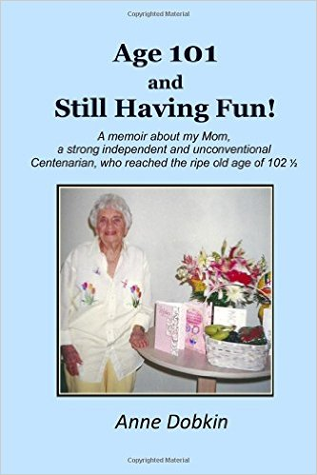

**Anne Dobkin, *Age 101 and Still Having Fun* (NF, A)**

[**https://www.amazon.com/Age-101-Still-Having-unconventional/dp/1508959773/**](https://www.amazon.com/Age-101-Still-Having-unconventional/dp/1508959773/)

A memoir about my Mom, a strong, independent and unconventional centenarian who reached the ripe old age of 102. What intrigued me to write about Mom was that she lived life her way, overcoming adversity and persevered through many hardships, constantly striving to live a long, healthy life in order to reach her goal of 100 years of age.

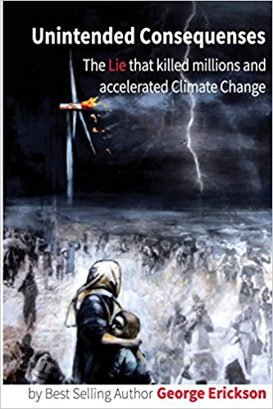

**George Erickson, *Unintended Consequences: The Lie that killed millions and accelerated Climate Change* (NF, A)**

<https://www.amazon.com/Unintended-Consequences-millions-accelerated-Climate/dp/1542944112>

This book is intended for the general public. It is comprehensive, stressing the seriousness of climate change, the safety and efficiency of nuclear energy, misunderstandings about radiation safety, and the exposure of the tactics and motives of those who oppose nuclear power but support inefficient, deadly, environment-damaging alternatives.

[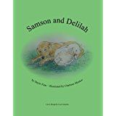](https://www.amazon.com/Samson-Delilah-Dayle-Finn/dp/1537622994/ref=sr_1_2?s=books&ie=UTF8&qid=1486295516&sr=1-2&keywords=dayle+finn)

**Dayle Finn, *Samson and Delilah,* (NF, C)**

<https://www.amazon.com/Samson-Delilah-Dayle-Finn/dp/1537622994/ref=sr_1_2?ie=UTF8&qid=1486242463&sr=8-2&keywords=Dayle+Finn>

*Samson and Delilah* is a true story of an unusual friendship between a yellow Labrador retriever, a white goose, and two people, Mr. and Mrs. Brown.

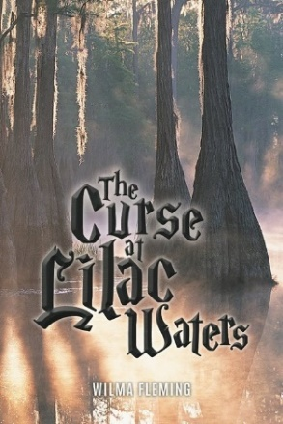**Wilma Fleming, *The Curse at Lilac Waters* (F, C)**

[**https://www.amazon.com/s/ref=nb_sb_noss_2?url=search-alias%3Dstripbooks&field-keywords=The+Curse+at+Lilac+Waters**](https://www.amazon.com/s/ref=nb_sb_noss_2?url=search-alias%3Dstripbooks&field-keywords=The+Curse+at+Lilac+Waters)

Deep within a spooky Florida forest, the trolls, goats, alligators and magic endure. Can a lost troll, her boyfriend, and one human boy foil the evils and break a curse?

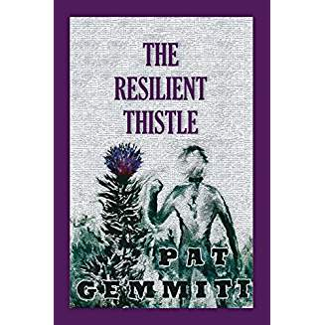

**Pat Gemmiti, *The Resilient Thistle* (F, A)**

<https://www.amazon.com/Resilient-Thistle-Pat-Gemmiti/dp/1717381677/>

Inspired by the true story of 5,000 bloody forgotten Scotsmen taken as prisoners-of-war in 1650 by Oliver Cromwell at the Battle of Dunbar. Daniel MacDhughill, Robert Junkins, Alexander Maxwell and John McKinney are thrown into inconceivable mayhem. Their privations create a new definition of hardship as they endure deplorable challenges of adversity and cruelty on two continents, armed only with the bonds of friendship, tenacity, resilience and courage. Almost four hundred years ago, these bráthairs, comrades, neighbors and friends shared a journey to hell and back, reclaimed their souls and helped form this New World. A mind-boggling story of extraordinary survival.

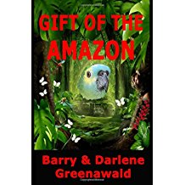**Barry & Darlene Greenawald, *Gift of the Amazon* (F, A)**

<https://www.amazon.com/Gift-Amazon-Barry-Greenawald/dp/0999544101/>

How far would you go to save someone you love? With every medical option exhausted, Deirdre is determined to save her dying eight-year-old niece. Hope comes in the form of an ancient myth. If the story of the gift of healing is true, can she find it? An Amazon parrot’s legendary lineage might be the key to unlocking the secret hidden for centuries in the Amazon rainforest. Hampered by a greedy faith healer seeking to destroy his competition, Deirdre must make life and death decisions. She also has a promise to keep. What will she have to sacrifice to save the one she loves? The authors masterfully weave together two tales. One is a daring adventure. The other is a heartwarming, moving story of hope against all odds, loss, and the complexities of human and animal emotion.

[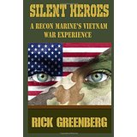](https://www.amazon.com/Silent-Heroes-Marines-Vietnam-Experience/dp/1522742808/ref=sr_1_1?s=books&ie=UTF8&qid=1486295565&sr=1-1&keywords=silent+heroes)

**Rick Greenberg, *Silent Heroes* (NF, A)**

[https://www.amazon.com/Silent-Heroes-Marines-Vietnam-Experience/dp/1522742808/](https://www.amazon.com/Silent-Heroes-Marines-Vietnam-Experience/dp/1522742808/%20)

True life story of Rick Greenberg’s experiences in Viet Nam. One reviewer wrote: “Raw emotional account had me on the edge of my seat at times and in tears at others. War is hell and if you didn't know it before, you really know it after reading this poignant account of this marine's experience.”

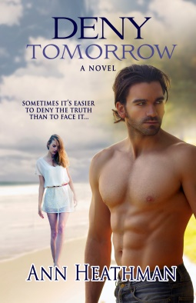**Ann Heathman, *Deny Tomorrow* (F, A)**

<https://www.amazon.com/Deny-Tomorrow-Ann-Heathman-ebook/dp/B06XBPH6Y4/>

**AUDIO BOOK:** <http://www.audible.com/offers/30free?asin=B073BDWXZZ>

When truth leads to heartache and death, sometimes it's easier to deny truth than face it. Special Ops leader Zach Acevedo takes his team undercover to assassinate the region's prominent warlord. He finds Arianna Garrett, a beautiful investigative journalist hiding beneath a burqa. Zach fights to protect Arianna from the danger she faces if discovered, while Arianna strives to expose the team's covert activities. When the truth surfaces and lives are at risk, who will compromise integrity to hold onto love?

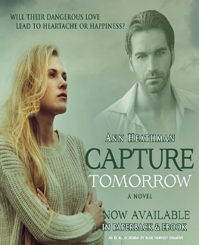

**Ann Heathman, *Capture Tomorrow* (F, A)**

<https://www.amazon.com/Capture-Tomorrow-Ann-Heathman-ebook/dp/B06XBJZ6MT/>

Sometimes love is dangerous. In this sequel to Deny Tomorrow, star crossed lovers Zach Acevedo and Arianna Garrett have to overcome obstacles in order to be together, but there are secrets that might doom the relationship. Arianna’s documentary on the plight of women under the Taliban causes her to be placed on a Jihad hit list. She narrowly escapes with her life. Her notoriety casts unwanted attention on Zach, who fears he may be outed as a CIA operative working undercover. Can these star-crossed lovers survive in this environment? Doubts, deceptions, and death threats must all be overcome in order to find lasting love.



**Ann Heathman, *Chasing Tomorrow* (F, A)**

<https://www.amazon.com/Chasing-Tomorrow-Ann-Heathman-ebook/dp/B06VYFCS2C>

Will tomorrow be only a memory if they can’t find today? In his line of work, disrupting terrorist’s networks, CIA Special Ops Zach Acevedo knows the evil that lurks in the world. When the love of his life, Arianna Garrett, lands her dream job as a foreign correspondent for a major network, he begs her not to go abroad to cover current terrorist events. But Arianna only has one thing on her mind - following the trail of know jihadist, Amira Shabab. Now she must face the consequences of her decision, including the possibility of losing Zach and everything she loves.

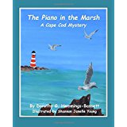**Dorothy G. Hemmings-Bassett, *The Piano in the Marsh, A Cape Cod Mystery*(F, C)**

[**https://www.amazon.com/Piano-Marsh-Cape-Cod-Mystery/dp/1518610854/**](https://www.amazon.com/Piano-Marsh-Cape-Cod-Mystery/dp/1518610854/)

Fictitious account capturing the mystery of the piano's journey from abandonment to discovery to relocation in a permanent home. This colorful children's picture book was funded in part by the Massachusetts Cultural Council.

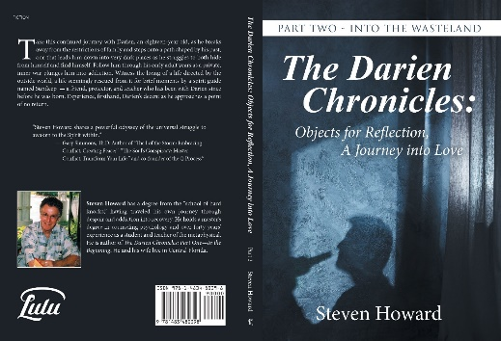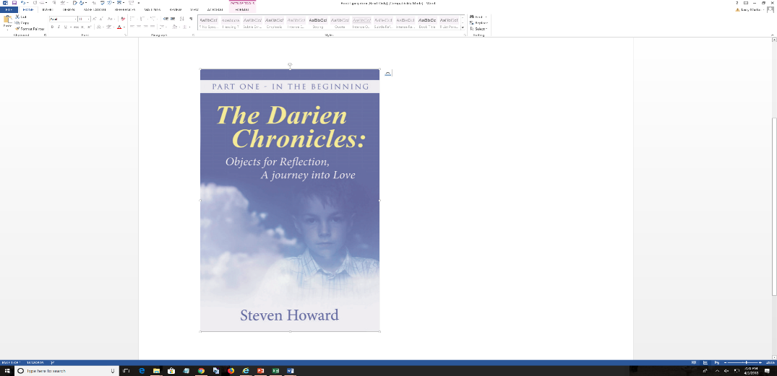

**Steven Howard (Steve Camp) *The Darien Chronicles: Objects for Reflection, A Journey into Love, Part One* (F, A)**

<https://www.amazon.com/Darien-Chronicles-Objects-Reflection-journey/dp/1504356357/>

Take a journey with Darien and his spirit guide from pre-birth into the after-life. In *The Darien Chronicles: Object for Reflection: A Journey into Love, Part One –In the Beginning*, walk with him as he leaves behind vague recollections of being a cast off and develops his rules for survival in the drama of an adoptive family where secrets thrive. Be with him as he struggles to separate truth from fiction and find his own soul.

**Steven Howard (Steve Camp) *The Darien Chronicles: Objects for Reflection, A Journey into Love, Part Two* (F, A)**

<https://www.amazon.com/Darien-Chronicles-Objects-Reflection-Wasteland/dp/1483480399/>

Take this continued journey with Darien, an eighteen-year old, as he breaks away from the restrictions of family and steps onto a path shaped by his past, one that leads him down into very dark places as he struggles to both hide from himself and find himself. Follow him through his early adult years as a private, inner war plunges him into addiction. Witness the living of a life directed by the outside world, a life seemingly rescued from it, for brief moments, by a spirit guide named Sundeep, a friend, protector and teacher that has been with Darien since before he was born. Experience, firsthand, Darien's decent as he approaches a point of no return.

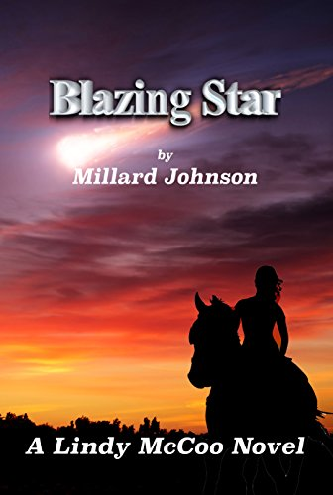**Millard Johnson, *Blazing Star* (A, F)**

<https://www.amazon.com/Blazing-Star-Lindy-McCoo-Stories-ebook/dp/B07CLSCWD4/>

Lindy McCoo loves three things in life: riding his two horses, Tux and Rebel, in the forests and fields of the Pacific Northwest, chasing women, and catching salmon and steelhead trout in the cold waters of his native Washington State. His occupation, freelance livestock insurance investigator, gives him time and opportunity to engage in all three pastimes. Lindy is a happy man, until his longtime friend and former partner, Fred Nightwalker is murdered while investigating a simple horse trailer accident. Fred leaves Lindy eight-hundred-fifty thousand dollars and responsibility for his sixteen-year-old orphan granddaughter, Blazing Star. Star is a sassy, rebellious teen hell-bent for trouble. The only advice Fred offers in his will is: Teach her to ride, it’s the only shot she has got. Come along with Lindy and Star as they follow the path of Fred’s murderer, a trail that leads through some of the most beautiful riding country in the United States with stops along the way to pursue for some great fishing and dalliance with some women you won’t soon forget.

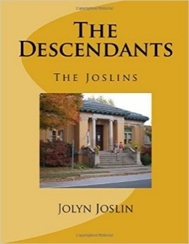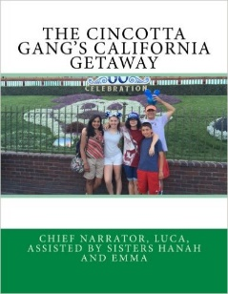

**Jolyn Joslin (Burt), *The Cincotta Gang's California Getaway***

<https://www.amazon.com/Cincotta-Gangs-California-Getaway/dp/1539940748/>

**Jolyn Joslin, *The Descendants: The Joslins* (NF, A)**

https://www.amazon.com/Descendants-Joslins-Ms-Jolyn-Joslin/dp/1535131608/

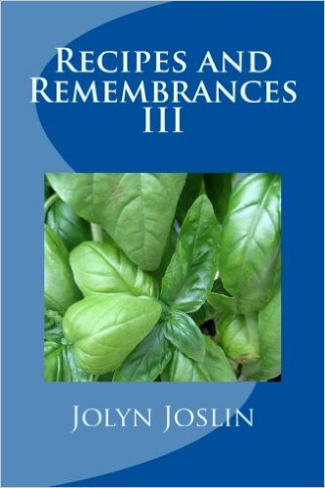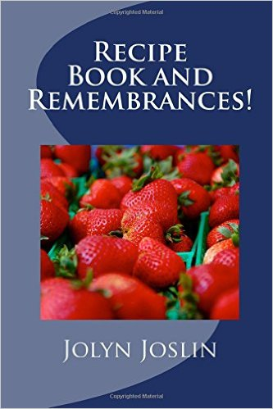

**Jolyn Joslin, *Recipe Book and Remembrances!* (NF, A)**

https://www.amazon.com/Recipe-Book-Remembrances-Jolyn-Joslin/dp/1522812431/

**Jolyn S. Joslin, *Recipes and Remembrances III* (NF, A)**

<https://www.amazon.com/Recipes-Remembrances-Mrs-Jolyn-Joslin/dp/153463858X/>

**Peggy Kime, *Hoof Prints On Her Heart* (C, YA – fiction)**

<https://www.amazon.com/Hoof-Prints-Heart-Peggy-Kime/dp/1530924677/ref=sr_1_1?ie=UTF8&qid=1486500992&sr=8-1&keywords=Hoof+Prints+On+Her+Heart>

Marcie is ridiculed by the most popular girls in her class. Through her friendship with a beautiful horse, her experiences in the show ring, and a surprising confrontation, she bests the bullies and discovers how to be the best you can be in spite of problems. An insight into the horse world, especially great for young girls who are “horse crazy”.

**Peggy Kime, *Changing Places* (NF, A)**

<https://www.amazon.com/Changing-Places-Peggy-Kime/dp/1540805824/>

A memoir. When Peggy’s husband chooses a career in heavy construction, she finds the best place to raise children is not by a series of dam sites. This book is funny and takes an inspiring look at the modern family maintaining their sense of humor as they are always **Changing Places**.



**Dan Kincaid, *Your…Chattahoochee National Forest* (NF, A)**

https://www.amazon.com/Your-Chattahoochee-National-Forest-Kincaid/dp/1536842249/

A historical collection of outdoor, natural resource, and national forest newspaper columns, written primarily by the author, from December 1978 - June 1980. These columns appeared in newspapers in north Georgia.



**Dan Kincaid, *Huntington Vinson’s Penicillin Kids* (NF, A)**

https://www.amazon.com/Penicillin-Kids-Dan-Kincaid/dp/1514334585/

A first-person account of a high school basketball team's totally unexpected run to a state championship in West Virginia in 1966. For those readers familiar with the movie *'Hoosiers'*, this is a very similar tale. Learn why the team was nicknamed 'The Penicillin Kids'.

[](https://www.amazon.com/Your-Wayne-National-Forest-Three/dp/1986076482/ref=sr_1_7?ie=UTF8&qid=1535639540&sr=8-7&keywords=dan+kincaid)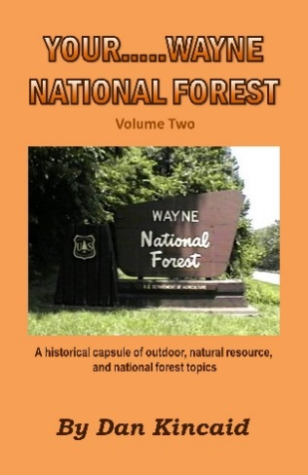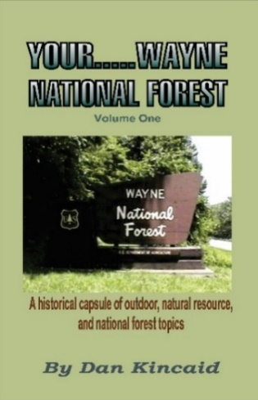

**Dan Kincaid, *Your…Wayne National Forest* (NF, A)**

A collection of the author's weekly newspaper columns covering outdoor, natural resource, and national forest topics. Written for newspaper outlets in southeastern Ohio.

Volume 1: 1981-1982 <https://www.amazon.com/Your-Wayne-National-Forest-One/dp/1523612959/>

Volume 2: 1983-1986 https://www.amazon.com/Your-Wayne-National-Forest-Two/dp/197811382X/

Volume 3: 1987-1989. Numerous columns in this volume relate to Wayne National Forest’s supplying the 1987 Christmas tree

for the U.S. Capital. <https://www.amazon.com/Your-Wayne-National-Forest-Three/dp/1986076482/>

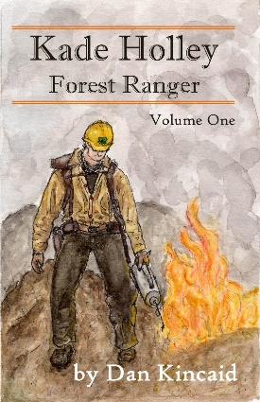**Dan Kincaid, *Kade Holley, Forest Ranger, Volume 1* (F, YA)**

Volume 1: <https://www.amazon.com/Kade-Holley-Forest-Ranger-Vol/dp/1548026980/>

Kade Holley is a Forest Ranger with the U.S. Forest Service, protecting and managing the natural resource gems of this country – the National Forests. Kade has a life threatening adventure on a remote lake in the vast wilderness of northern Minnesota’s Superior National Forest; a fire situation in the pine forests of the North Carolina Piedmont; and an encounter with a group of armed and drunken vandals intent on destroying Forest Service property in southeastern Ohio’s Wayne National Forest. There are truck wrecks; encounters with wild animals; and Kade leads a team of Forest Service specialists on an assignment to Mount St. Helens on the Gifford Pinchot National Forest in the state of Washington.

[](https://www.amazon.com/Kade-Holley-Forest-Ranger-Vol/dp/1722788135/ref=sr_1_5?ie=UTF8&qid=1535639911&sr=8-5&keywords=dan+kincaid)**Dan Kincaid, *Kade Holley, Forest Ranger, Volume 2* (F, YA)**

Volume 2: <https://www.amazon.com/Kade-Holley-Forest-Ranger-Vol/dp/1722788135/>

Five new adventures of Kade Holley, a Forest Ranger with the U.S. Forest Service. In this second volume Kade has an encounter with an angry bull moose in northern Minnesota's Superior National Forest; he deals with a black bear that is causing concern to hikers at Georgia’s Brasstown Bald on the Chattahoochee National Forest; and he becomes a witness when he sees poachers illegally shoot a huge buck deer on West Virginia's Monongahela National Forest. There is a "smelly" encounter with turkey vultures in Ohio's Wayne National Forest and Kade participates on a national fire prevention team in Colorado, where he unexpectedly gets to take a "harrowing" practice ride with up and coming race car driver Scott Dixon prior to the 2002 Denver Grand Prix. Through it all, Kade never waivers in his love for his family, his love of being a Forest Ranger, and his love of the National Forests. He understands that his work is sometimes dangerous, often challenging, but always fun and interesting. "That’s life as a “ranger,” Kade says. This book will take you through a series of adventures that many dream about, but very few ever experience.

[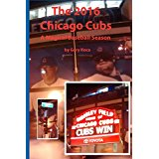](https://www.amazon.com/2016-Chicago-Cubs-Magical-Baseball/dp/1539961540/ref=sr_1_1?ie=UTF8&qid=1486303491&sr=8-1&keywords=gary+koca)

**Gary Koca, *The 2016 Chicago Cubs: A Magical Baseball Season* (NF, YA, A)**

https://www.amazon.com/2016-Chicago-Cubs-Magical-Baseball/dp/1539961540/

This book examines the Chicago Cubs’ entire 2016 season, including the playoffs and World Series, and the factors that led to their achievement after 108 years of misery. The book should appeal to the millions of Cub fans around the USA and world, as well as baseball fans in general.



**Bob Konig,** ***Of Good and Evil: Prelude to the Holocaust* (F, A)** <https://www.amazon.com/Good-Evil-Prelude-Holocaust/dp/1547192577/>

This historical fiction creates an intimate portrait of Adolf Hitler’s rise to power, beginning with his failed 1923 attempt to overthrow the Democratic Weimar Republic, and ending in 1939 with the start of World War II in Europe. The narratives’ main fictional characters are SS Lieutenant Colonel Claus Mayer, who will do anything to advance Adolf Hitler’s dream of a Jew-free Europe, and Jewess Rachel Goldstein, who will do anything to prevent that from happening. The novel spans the years 1923 to 1939. Please see Amazon page for more detailed synopsis. A sequel is in progress.

**Jeanne Leighton (Rosemary Houseknecht)**

***Never Say Never* (F, A)**

https://www.amazon.com/Never-Say-Never-Jeanne-Leighton/dp/1530662389/

Tessa McVey was hired by the president of a prestigious corporation. To her dismay she found she would be working with his son. Because of an earlier incident, the two hated one another on sight. Tessa eventually developed feelings for him and needed to find a way to compete with a supermodel, Samantha Stark. Good luck, Tessa.

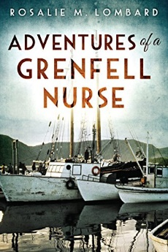

**Rosalie M. Lombard, *Adventures of a Grenfell Nurse* (NF, A)**

<https://www.amazon.com/Adventures-Grenfell-Nurse-Rosalie-Lombard-ebook/dp/B01N7WRA44/>

A riveting collection of stories that share the experiences of a Grenfell Nurse in the early 1950s in the subarctic climate of Newfoundland and Labrador: a train wreck, dog team trips, delivery of a baby on board a coastal steamship, a harrowing sailing experience, a near ship wreck in gale force winds, and much more!

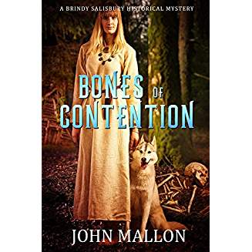

**John Mallon, *Bones of Contention* (F, A)**

[**https://www.amazon.com/Bones-Contention-Salisbury-Historical-Mystery-ebook/dp/B073YXKZJ8/**](https://www.amazon.com/Bones-Contention-Salisbury-Historical-Mystery-ebook/dp/B073YXKZJ8/)

Mid-wife, healer, and herbalist Brindy Salisbury followed her dog to a shallow grave in a nearby apple orchard after he brought her a human arm bone. She determined the remaining bones showed signs of a violent death of a young man missing for four years.  
 Despite protests that Brindy was a non-Christian woman and not skilled enough to make a valid judgment about the identification, she was requested to find the killer. With her niece and a local villager, they shifted through unfounded accusations and challenged reluctant witnesses who hampered their investigation.  
 Set in rural Somersetshire, England in the early 1700’s, Bones of Contention has a convincing plot and memorable characters. Intrigue and drama highlight this historical mystery.

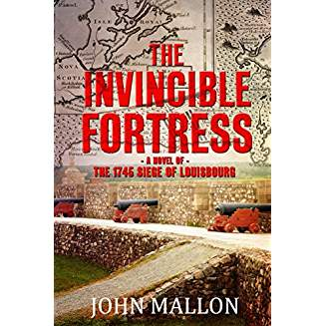**John Mallon, *The Invisible Fortress* (F, A)**

[**https://www.amazon.com/Invincible-Fortress-John-Mallon-ebook/dp/B07FSS8NGP/**](https://www.amazon.com/Invincible-Fortress-John-Mallon-ebook/dp/B07FSS8NGP/)

Daniel Bailey worked in Taunton, Massachusetts in the family’s import-export business and served as a captain in the town’s militia. In 1744 growing tensions between England and France disrupted his world and led to his appointment as aide and advisor to the colonial governor.   
 When the declaration of war reached French forces at the Ile Royale fortress of Louisbourg, they seized New England fishing boats and attacked coastal towns. In response, the Massachusetts governor sought military assistance from London and recruited 4,000 militiamen from New England colonies.  
 Because of Bailey’s ability to speak French and his knowledge of the fortress, he was promoted to colonel and assigned as the commanding general’s chief-of-staff. In 1745, with support from the Royal Navy blockading the harbor, the New Englanders lay siege to Louisbourg. After six weeks, the French surrendered the massive, stone-structure called the invincible fortress.

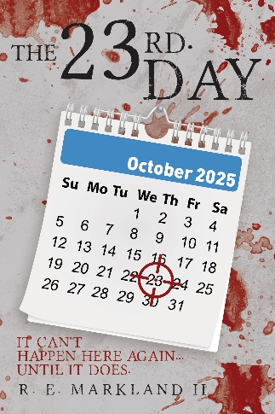**Ronald E. Markland, *The 23rd Day*, (F, A)**

<http://www.amazon.com/author/remarkland>[Thetwentythirdday@gmail.com](mailto:Thetwentythirdday@gmail.com)

It can’t happen here again… Until it does. When Mark Landre experienced The Beltway Sniper Murder spree firsthand, little did he know that over 20 years later he would discover a similar terrorist plot, BUT NOW ON STEROIDS! When sniper shootings begin to take place throughout small communities in the USA, the similarities go undetected by the local law enforcement agencies. One very simple conversation begins a search that ends up identifying the plan. The leader of the plan has developed a foolproof, undetectable method for direction of the sleepers now being activated to a sniper status. The targets of the terrorists are purely random, there is no tie to race, age, profession, or activity. Unless stopped immediately, the entire USA is in jeopardy of random murders. Due to a small error by the terrorist’s leader; the plan is discovered, this is the rest of the story, or is it?

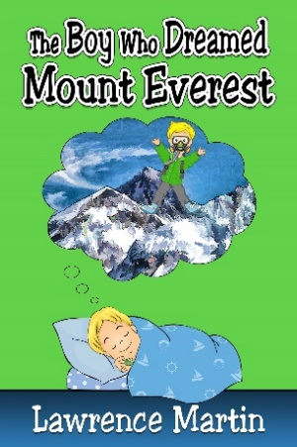

**Lawrence Martin, *The Boy Who Dreamed Mount Everest* (F, C)**

<https://www.amazon.com/Boy-Who-Dreamed-Mount-Everest-book/dp/B01LWSLS66/lakesidepress>

A 10-year-old boy, whose only climbing experience is an indoor rock wall, dreams of climbing Mount Everest. Night by night he gets closer to his goal – of being the youngest person ever to climb the world’s tallest mountain. Will he make it?

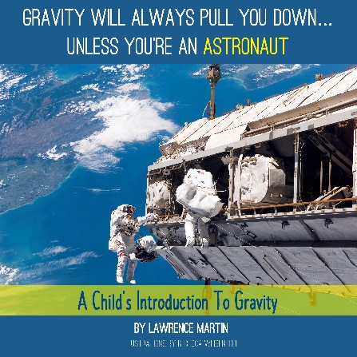

**Lawrence Martin, *Gravity Will Always Pull You Down…Unless You’re An Astronaut: A Child’s Introduction to Gravity* (NF, C)**

<https://www.amazon.com/s/ref=nb_sb_noss?url=search-alias%3Dstripbooks&field-keywords=Gravity+Will+Always+Pull+you+down>

Gravity Will Always Pull You Down...Unless You're an Astronaut is a fully-illustrated 40-page book for elementary school level. It explains why Astronauts float in space. Hint: it’s *not* because of zero gravity.

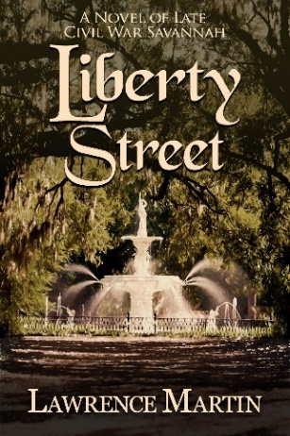**Lawrence Martin, *Liberty Street: A Novel of Late Civil War Savannah* (F, A)**

<https://www.amazon.com/Liberty-Street-Novel-Civil-Savannah-ebook/dp/B0748W3CTX/>

Abigale Tate, 24, has lost her father and husband in the Civil War, and now General Sherman is about to invade Savannah. She feels despondent and cynical. She attends a black church and is enthralled by the reverend, a free colored man. They have a furtive affair, which ends when she meets a Yankee major. Along the way she is beset by a teenage sister who has no boundaries in seeking love, a stalking German immigrant, and an outlaw brother who is hunted by the very man she hopes to marry.



**Lawrence Martin, *Visit to Liberty Street and Other Fiction* (F, A)**

<https://www.amazon.com/Visit-Sunnyville-Fiction-Lawrence-Martin-ebook/dp/B0786VD6QF/lakesidepress/>

The title story, VISIT TO SUNNYVILLE, is a novella. As the story unfolds a very strange and very tall object has just landed on a golf fairway of Sunnyville, Florida. Sunnyville, a large retirement community situated one hour north of Orlando, has an uncanny resemblance to The Villages. The world goes agog over the landing, but the local residents? They are more annoyed, by all the publicity, by the sudden arrival of National Guard troops, and by the interruption of their lifestyle. Now we have “real gates,” says one resident. “Why won’t it just go away?”

The book also includes 9 short stories (two were finalists in Florida Writers Association Royal Palm Literary Awards competition), several novel excerpts, and one “fictional review.” It is available in print format and on Amazon Kindle.

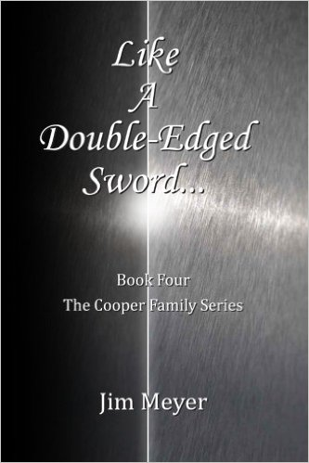

**Jim Meyer, Like a Double-Edged Sword (F, A)**

<https://www.amazon.com/Like-Double-Edged-Sword-Cooper-Family/dp/153770589X>

Henry, better known as Hank, is the first son who defies Charlie Cooper’s authority. He leaves home after an abrupt and violent confrontation with his father that leaves both of them on different sides of a double-edged sword. Through a series of confrontations for both father and son in the harsh deserts of Texas and Arizona and the Rocky Mountains finds both men dealing with Loss, death, life altering changes and a new beginning that brings them close together once again.

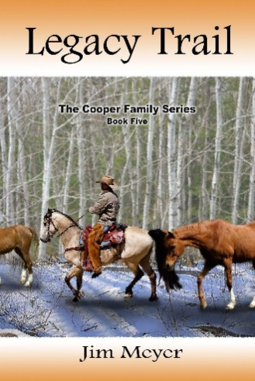**Jim Meyer, *Legacy Trail* (F, A)**

<https://www.amazon.com/Legacy-Trail-Cooper-Family-Book-ebook/dp/B06Y344L2J/>

Hank Cooper, the middle son of Charles and Margaret Cooper, must contend with being a widower with a newborn son. While most of the men from the ranches around Green Springs are on a cattle drive, Hank must get 400 horses from Green Springs, Wyoming to Omaha by December 15th. His father suggests hiring women. Hank thinks that is a crazy idea, but what choice does he have. He advertises for help and over 100 women show up at the community church. He chooses twenty, two of whom have children. He must balance an intimate relationship with his new wife Betty, 20 women, 4 children. He has less than a week to break with tradition and form the women into hardened trail-wise drivers, how to get along with each other, eat spicy food prepared by Jose, Timber Creek's cook. Legacy Trail has twists and turns with surprises along the way. As the time passes into 1917, the United States weighs its options on getting involved in World War I.

**Barbara Miller, *Keto for Life* (A, NF)**

<https://www.amazon.com/Keto-Life-Fat-Fueled-Approach-Weight-ebook/dp/B079HXRZPL/>

I believe that understanding why you keep gaining weight no matter how or what you do boils down to “what you eat.” This book will provide answers to the whys plus provide wonderful satiating recipes that are laid out for you each day to make it easy. There are over 125 recipes and you do not have to worry about the right ratios of fat, proteins and carbohydrates as I did it all for you. There are no counting calories or weighing portions, just prepare, eat and enjoy! Never diet again! The low fat high carb diets are a disaster that have never worked and never will. Kick the tasteless fake foods to the curb and allow yourself to enjoy the satisfying flavors of real food. The ketogentic diet is the way humans were meant to eat. It is simply the right balance of the macronutrients, fat, protein, and carbohydrates. Eating high fat foods, low to medium protein and low carbohydrates is the formula to ultimate weight-loss.

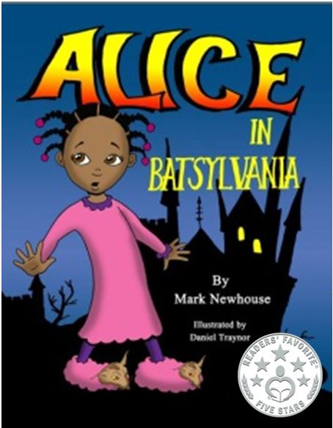**Mark Newhouse, *Alice in Batsylvania* (F, C)**

[**https://www.amazon.com/Alice-Batsylvania-Mr-Mark-Newhouse/dp/1530624193**](https://www.amazon.com/Alice-Batsylvania-Mr-Mark-Newhouse/dp/1530624193)

Picture book; Illustrated by Daniel Traynor

Reader's Favorite Seal and 1st Prize Florida Writers Association (unpublished picture book). Sassy Alice has been warned never to go with strangers, but does she listen? Humorous illustrations make this morality tale one everyone will enjoy.   $9.95

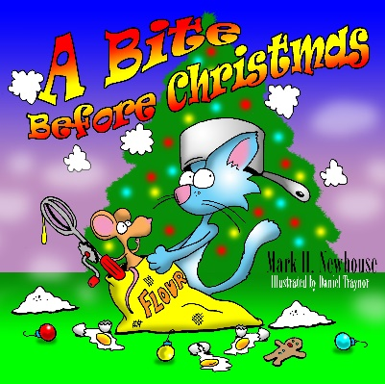

**Mark H. Newhouse, *A Bite Before Christmas* (F, C)**

<https://www.amazon.com/Bite-Before-Christmas-Mark-Newhouse/dp/1539301729/>

Illustrated by Daniel Traynor

The cat is after the mouse again? Can even a surprise visitor stop them? Funny rhyme, lively illustrations and simple drawing lessons, make this a holiday delight. $9.95

[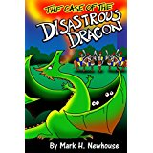](https://www.amazon.com/Case-Disastrous-Dragon-Tales-Monstrovia/dp/1537457594/ref=sr_1_3?s=books&ie=UTF8&qid=1486295699&sr=1-3&keywords=disastrous+dragon)**Mark Newhouse, *The Case of the Disastrous Dragon* (F, C)**

<https://www.amazon.com/Case-Disastrous-Dragon-Tales-Monstrovia-ebook/dp/B01N6D4V2T/>

In this sequel to the award-winning *Welcome to Monstrovia*, teen Brodie Adkins, with the help of Emily Beanstalk and famous lawyer Doofinch the Defender, try to save a dragon from prison to avoid total disaster. Now a Top Ten new Children’s Book in the P&E Readers Poll.

**Mark Newhouse, *Passover Puppy Coloring Book* (F, C)**

<https://www.amazon.com/Passover-Puppy-Coloring-Mark-Newhouse/dp/1945493046/>

****He’s back and sneakier than he was in Dreidel Dog. Kids of all ages will love coloring in this fun rhyming story by multi-award-winning Mark and illustrator, Dan Traynor, as they learn the story of Passover. Bad puppy! But cute! Please add your reviews on Amazon.

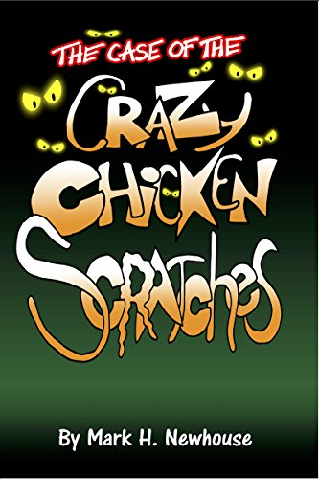

**Mark Newhouse, *The Case of the Crazy Chickenscratches* (F, C)**

[**https://www.amazon.com/Case-Crazy-Chickenscratches-Tales-Monstrovia-ebook/dp/B07D5CFKCS/**](https://www.amazon.com/Case-Crazy-Chickenscratches-Tales-Monstrovia-ebook/dp/B07D5CFKCS/)

Brodie is back in this sequel to the award-winning Welcome to Monstrovia! Brodie must make a difficult decision while uncovering the hilarious secret of the crazy Chickenscratches.

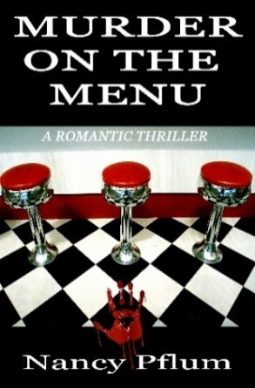**Nancy Pflum, *Murder on the Menu* (F, A**)

<https://www.amazon.com/Murder-Menu-Nancy-Pflum-ebook/dp/B07D1S3GD3/>

Four sinister men arrive in Shipley, Ohio, shattering the peace and security of Suzanne Moore’s life. Her boss is on the verge of bankruptcy as are two other shop owners on the same block. Another merchant is mysteriously missing. Will Suzanne be able to figure out why they are being terrorized before she loses everything, including her life?

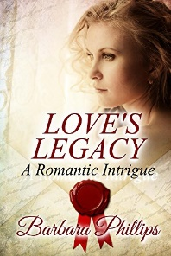

**Barbara Phillips*, Love’s Legacy: A Romantic Intrigue* (F, A)**

<https://www.amazon.com/Legacy-Romantic-Intrigue-Barbara-Phillips-ebook/dp/B017HOW2PM/>

Love, murder, duplicity and romance are the forces which touch Chloe Fairfax and her husband William Crandall’s lives. A year after their wedding they travel to meet Williams’ mother and brother. On their way, the couple is waylaid by three armed highwaymen.

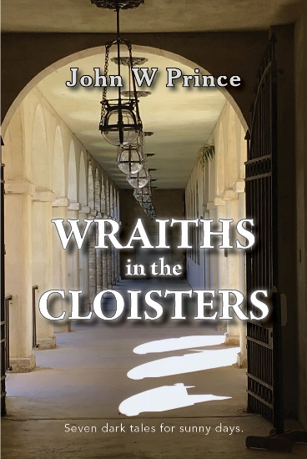**John Prince, *Wraiths in the Cloisters--Seven dark tales for sunny days* (A, F)**

<https://www.amazon.com/Wraiths-Cloisters-Seven-tales-sunny/dp/1724629557/>

A man learns to levitate – or fly! But then what? Does he need a whole new set of friends? His mother was his protector and best friend. Now that his mother is dead, who’s going to protect him from the Evil Resident in his head? Jimmy Collins was his father. Always talking. Always being in the forefront. Now Jimmy is dead, and the wake is over, and the headaches have begun. And the beer is tasting strange. When Hilldog finds an old bicycle that can speak, his life takes on new meaning. Then he’s forced to tell a long fairy tale that includes a “Happily Ever After” ending. He knew the two women waiting for an Uber, sheltering from the rain. Names, jobs, boyfriends and everything. He also knew the enemy soldiers were waiting for him up on the Highline. Heaven is, well, heaven. And eternity is a very long time. Hopefully, not too long. But then, who knows? The sisters grew up and grew old together. They were the only ones left. Then one night, unexpectedly, they came to know each other. They followed him all of this life, never quite catching up. Now they’re here. So, what happens when your worst fears finally walk in the door?

**Mark Pryor, *Noble Phoenix* (F, A)**

<https://www.amazon.com/Noble-Phoenix-Mark-Pryor-ebook/dp/B07465QGCW/>

A secret organization has unleashed terrorism across Europe, and Perseus, the grand master of Arcadian Spear, is not stopping there. He plans to use the ultimate weapon. Viktor Prazsky, who has a secret weapon of his own, risks everything to stop him. The relentless action and frightening technologies leap from today’s and tomorrow’s headlines. Can Viktor save the world from Armageddon?

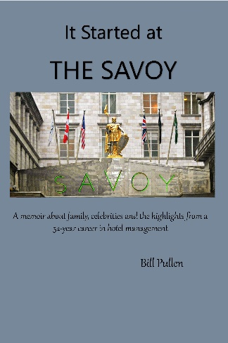**Bill Pullen, *It Started at The Savoy* (NF, A)**

<https://www.amazon.com/Started-Savoy-celebrities-highlights-management/dp/1542992060/>

A memoir about family, celebrities and the highlights from a 52-year career in hotel management. The author has managed hotels from an historic country inn in England to the only modern hotel in Suriname, South America and the 1300-acre Playboy conference resort in Lake Geneva, Wisconsin. The book contains many humorous and fascinating stories with behind-the-scenes experiences. Celebrity interaction includes Bob Hope, Sonny and Cher, Phyllis Diller, Princess Grace of Monaco and many others.

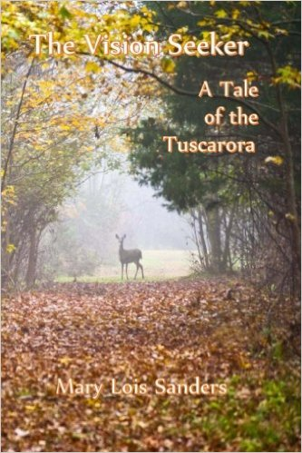**Mary Lois Sanders, *The Vision Seeker* (F, YA & A)**

<https://www.amazon.com/Vision-Seeker-Tale-Tuscarora/dp/1492793493/>

VISION-SEEKER sees a vision of an attack on her Tuscarora village, but many don’t believe her. When the attack comes she is left the oldest of 20 surviving children. She knows she must use her vision to guide them to safety, but can she?

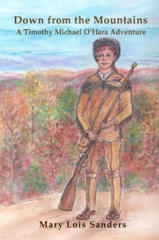**Mary Lois Sanders, *Down from the Mountains, A Timothy Michael***

***O’Hara Adventure, Book 1* (F, C)**

<https://www.amazon.com/Mountains-Timothy-Michael-Adventure-Adventures-ebook/dp/B00GANVSK2/ref=sr_1_9?s=books&ie=UTF8&qid=1486862783&sr=1-9&keywords=Mary+Lois+Sanders>

In 1774, as his pa’s dying, TIMOTHY (12) promises to leave the Allegheny to find his guardians. But Tim begins his journey east not sure he wants to go. When he is kidnapped and taken south, he must find a way to escape or be sold into bond slavery.



**Katherine Edwins Schumm, *Fearless* (NF, A)**

[https://www.amazon.com/Fearless-Katherine-Edwins-Schumm/dp/154087799X/](https://www.amazon.com/Fearless-Katherine-Edwins-Schumm/dp/154087799X/%20)

A young American missionary, Alfreda Edwins, faces off a lawless group of soldiers beating one of their compatriots. Accompanied by a band of young Chinese children, she must decide whether to choose safety, hers and the children’s, or stand up for her beliefs and risk death. A true story about a fearless woman from Wisconsin in Central China in 1924.

**Estella Shivers, *A Long Journey to the White Picket Fence & Green Grass* (A, NF)**

<https://www.amazon.com/Journey-White-Picket-Fence-Green-ebook/dp/B078X34D23/>

To escape from a life of great hardship and poverty to a place of tremendous possibilities was just a dream, but who says a dream could not come true? Born and raised by her mother in Bluefields, Nicaragua, Estella Victoria Frederick Shivers, her brother and two sisters were suddenly and unexpectedly brought to live with their father in the United States of America.

At the age of nine, Estella finally met her father, a merchant seaman from Grand Cayman Island, who was now a US citizen. Their separation took place when she was just an infant. Such an opportunity allowed her to find her own pot of golden life.

Join Estella as she travels on *A Long Journey to the White Picket Fence & Green Grass*. This tells the story of her triumph from the life of “Hell” to a place she calls “Heaven on Earth!”

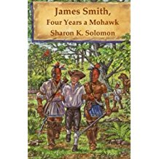

**Sharon Solomon, *James Smith, Four Years a Mohawk* (F, YA)**

<https://www.amazon.com/James-Smith-Four-Years-Mohawk/dp/069290283X/>

*James Smith, Four Years a Mohawk*, is a teen historical fiction novel that takes place during the French and Indian War. Sixteen-year-old James Smith is captured by Mohawks in Pennsylvania in 1755. He is eventually adopted by them and renamed Scoouwa. James is conflicted about running away or staying with the tribe. Is he still James or is he Scoouwa? Only James can decide.

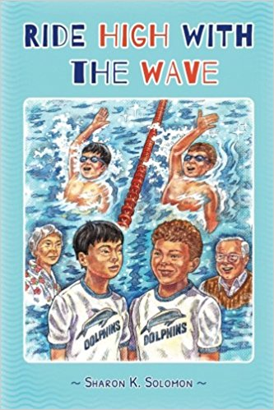**Sharon Solomon, *Ride High With The Wave* (F, YA)**

<https://www.amazon.com/Ride-High-Wave-Sharon-Solomon/dp/0986088250/>

*Ride High with the Wave* is a novel for ages 8-12 about two swim team rivals. Ted and Hiro don't much like each other but need to work together to solve their mutual problem, attending swim meets on Saturdays. Ted goes to temple and Hiro goes to Japanese School, so with advice in the form of proverbs from their grandparents, the boys try to change the swim meets to Sundays. Eventually Ted and Hiro do solve their problem and, by this time, have become good friends. This multicultural, multigenerational book will appeal to swimmers and to anyone who enjoys a good story.

**On Wed, Dec 13, 2017 at 4:29 PM, Larry Martin <**[**drlarry437@gmail.com**](mailto:drlarry437@gmail.com)**> wrote:**

**This email is, first of all, to wish all members of our Villages writing community Happy Holidays. It is another festive season, which means lots of Holiday parties here in TV (and a challenge -- to me at least -- not to gorge when I attend them).  The season also means preparation for January events, and with that in mind I am listing below the upcoming events pertaining to our club, along with TWO IMPORTANT DEADLINES (highlighted in yellow).  All this information is also in the WLOV newsletter sent out last week, and online at** [**www.wlov.org**](http://www.wlov.org/)**.**

**Larry Martin**

**Past President**

**Writers League of The Villages**

**Wed, Jan 3**

**Laurel Manor Rec Center, 8:30 – 10:30 a.m.**

**Florida writer, book coach and publishing consultant Rik Feeney will present Marketing for Book Events.**

**Wed, Jan 3**

**Laurel Manor Rec Center, noon to 3:30 p.m.**

**Mr. Feeney will present a seminar on Marketing Your Kindle Book. Cost is $25.  Please click link below for registration form.**

[**http://wlov.weebly.com/uploads/2/4/3/6/24362452/rik_feeney_workshop_registration**](http://wlov.weebly.com/uploads/2/4/3/6/24362452/rik_feeney_workshop_registration)

**Jan 17-24**

**Annual Book Cover Contest. Open to all WLOV members and anyone who has reserved a table at Expo ’18 to sell books. Please click link below for registration form**

[**http://wlov.weebly.com/uploads/2/4/3/6/24362452/2018-bookcovercontestentryform.pdf**](http://wlov.weebly.com/uploads/2/4/3/6/24362452/2018-bookcovercontestentryform.pdf)

**DEADLINE TO ENTER BOOK COVERS IS JANUARY 3rd.**

**Sat, Jan 27**

**WLOV’s Central Florida Book & Author Expo**

**Eisenhower Recreation Center, 10 am – 3 pm. More info on** [**www.wlov.org**](http://www.wlov.org/) **home page, including Guidelines for authors who will be displaying books.**

**About Expo, see the recent *Villages Daily Sun* interview with Mark Newhouse, posted on WLOV’s Facebook page at**

[**https://www.facebook.com/pg/The-Writers-League-of-The-Villages-162776817086391/posts/?ref=notif**](https://www.facebook.com/pg/The-Writers-League-of-The-Villages-162776817086391/posts/?ref=notif)

**Wed, Feb 7**

**General Meeting. Laurel Manor Rec Center, 8:30 – 10:30 a.m. Chris Coward will discuss Book Contests and Competitions.**

**Wed, Feb 14**

**Valentines’ Day Story Readings, Fenney Rec Center, 6 to 8 pm. Light refreshments**

**served. Please click link below for the submission form for your story or poem.**

[**http://wlov.weebly.com/uploads/2/4/3/6/24362452/valentines-day-lovestory-submission-form.pdf**](http://wlov.weebly.com/uploads/2/4/3/6/24362452/valentines-day-lovestory-submission-form.pdf)

**DEADLINE FOR SUBMISSIONS IS JANUARY 1st.**

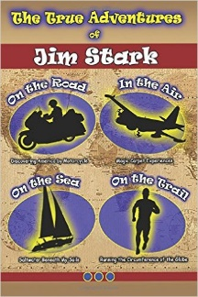**Jim Stark, *The True Adventures of Jim Stark* (NF, A)**

<https://www.amazon.com/True-Adventures-Jim-Stark-ebook/dp/B01MXZGUI5/ref=sr_1_1?ie=UTF8&qid=1486240343&sr=8-1&keywords=true+adventures+of+jim+stark>

A collection of stories learned by the author as a Navy pilot and a forty-year general aviation flyer; a sailor who sailed the Atlantic, Pacific, Caribbean, and Adriatic Seas; a marathoner who ran more miles than the circumference of the Earth; and a motorcyclist who traveled thousands of miles discovering North America’s scenic beauty and fascinating history.

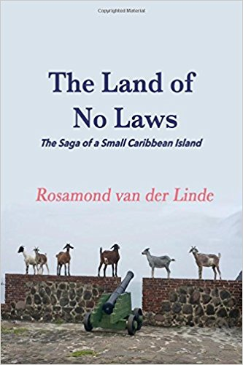**Rosamond van der Linde, *The Land of No Laws. The Saga of a Small Caribbean Island* (NF, A)**

<https://www.amazon.com/Land-Laws-Rosamond-van-Linde/dp/1977703674/>

Shortly after moving to the volcanic island of Saint Eustatius, Rosamond launched into her favorite mode - piano lessons. She was immediately arrested and threatened with deportation. These are the stories of the ups and downs from her thirty years spent living in the Caribbean. Ms. van der Linde is also author of the piano-themed book, *A Piano in Every Room*, published in 2010.

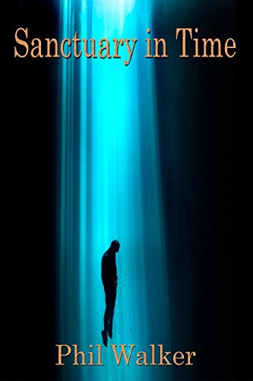**Phil Walker, *Sanctuary in Time* (F, A)**

<https://www.amazon.com/Sanctuary-Time-Phil-Walker-ebook/dp/B07DH23PS1/>

Scientists have discovered a way to travel back in time.   
Fearing changes in the past may alter the present, Admiral Jonas Cisco builds the city Sanctuary as a refuge against such a cataclysm.  
But, an evil man plots to change history for motives of his own. The Gateway, which makes time travel possible, is seized. The timestream is broken and the world, as we know it, blinks out of existence.  
Sanctuary is left alone, isolated.  
Now Cisco must lead the courageous people of Sanctuary, against impossible odds, to restore the fracture.   
Time is not on his side.

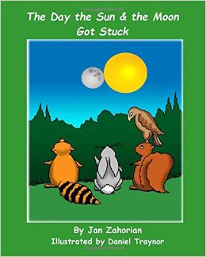

**Jan Zahorian, *The Day the Sun & the Moon Got Stuck* (F, C)**

<https://www.amazon.com/Day-Sun-Moon-Got-Stuck/dp/1533555346>

In a beautiful forest beside a great river lived daytime (DT) and night-time (NT) animals. The DTs only left their homes during the day, the NTs only at night. They had never met each other. In fact, each group believed “the others” were mysterious, scary and even dangerous! Then one day everything changed. The sun and the moon got stuck at the top of the sky! Was it daytime or nighttime? Not one of the animals of the forest knew. This was a problem the DTs and NTs would have to solve together.