Linda Richards, The Villages Magazine, October 2019

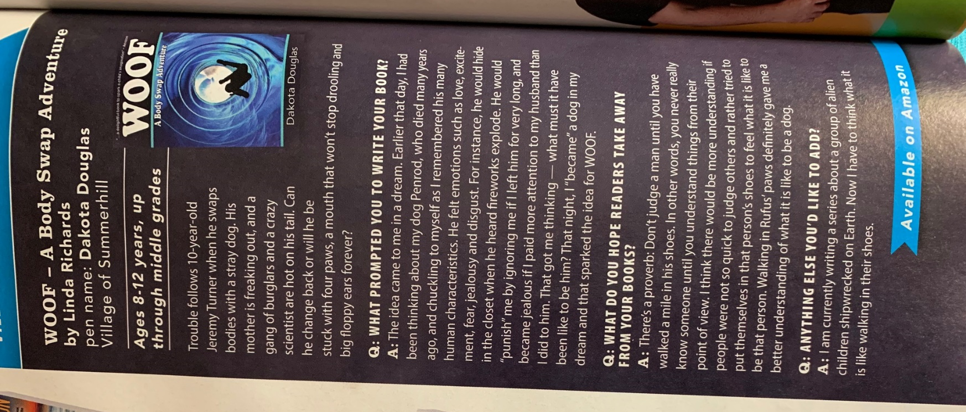

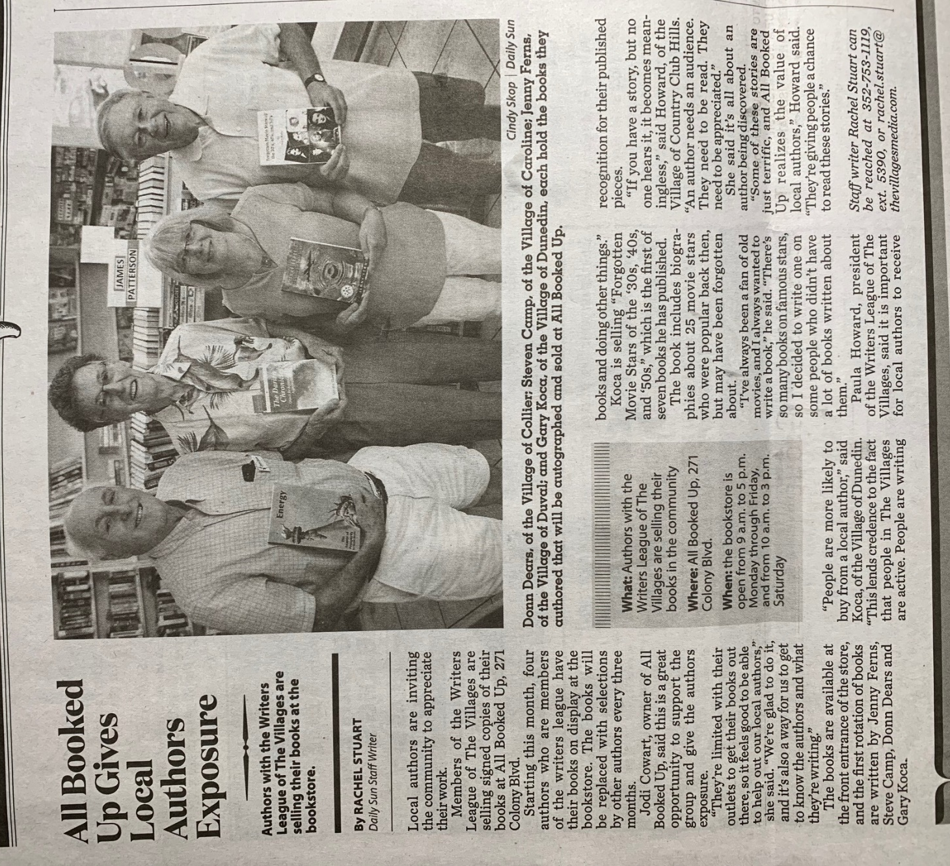
Donn Dears, Steven Camp, Jenny Ferns, Gary Koca
The Villages Daily Sun, October 3, 20 19

