News items about WLOV authors, March 2019

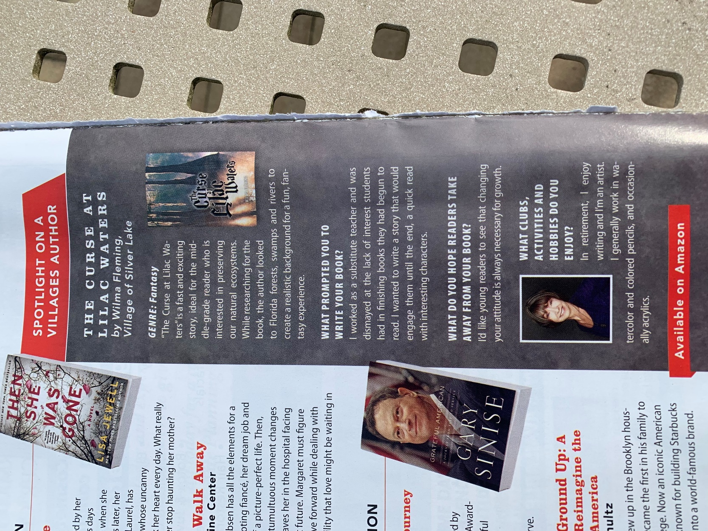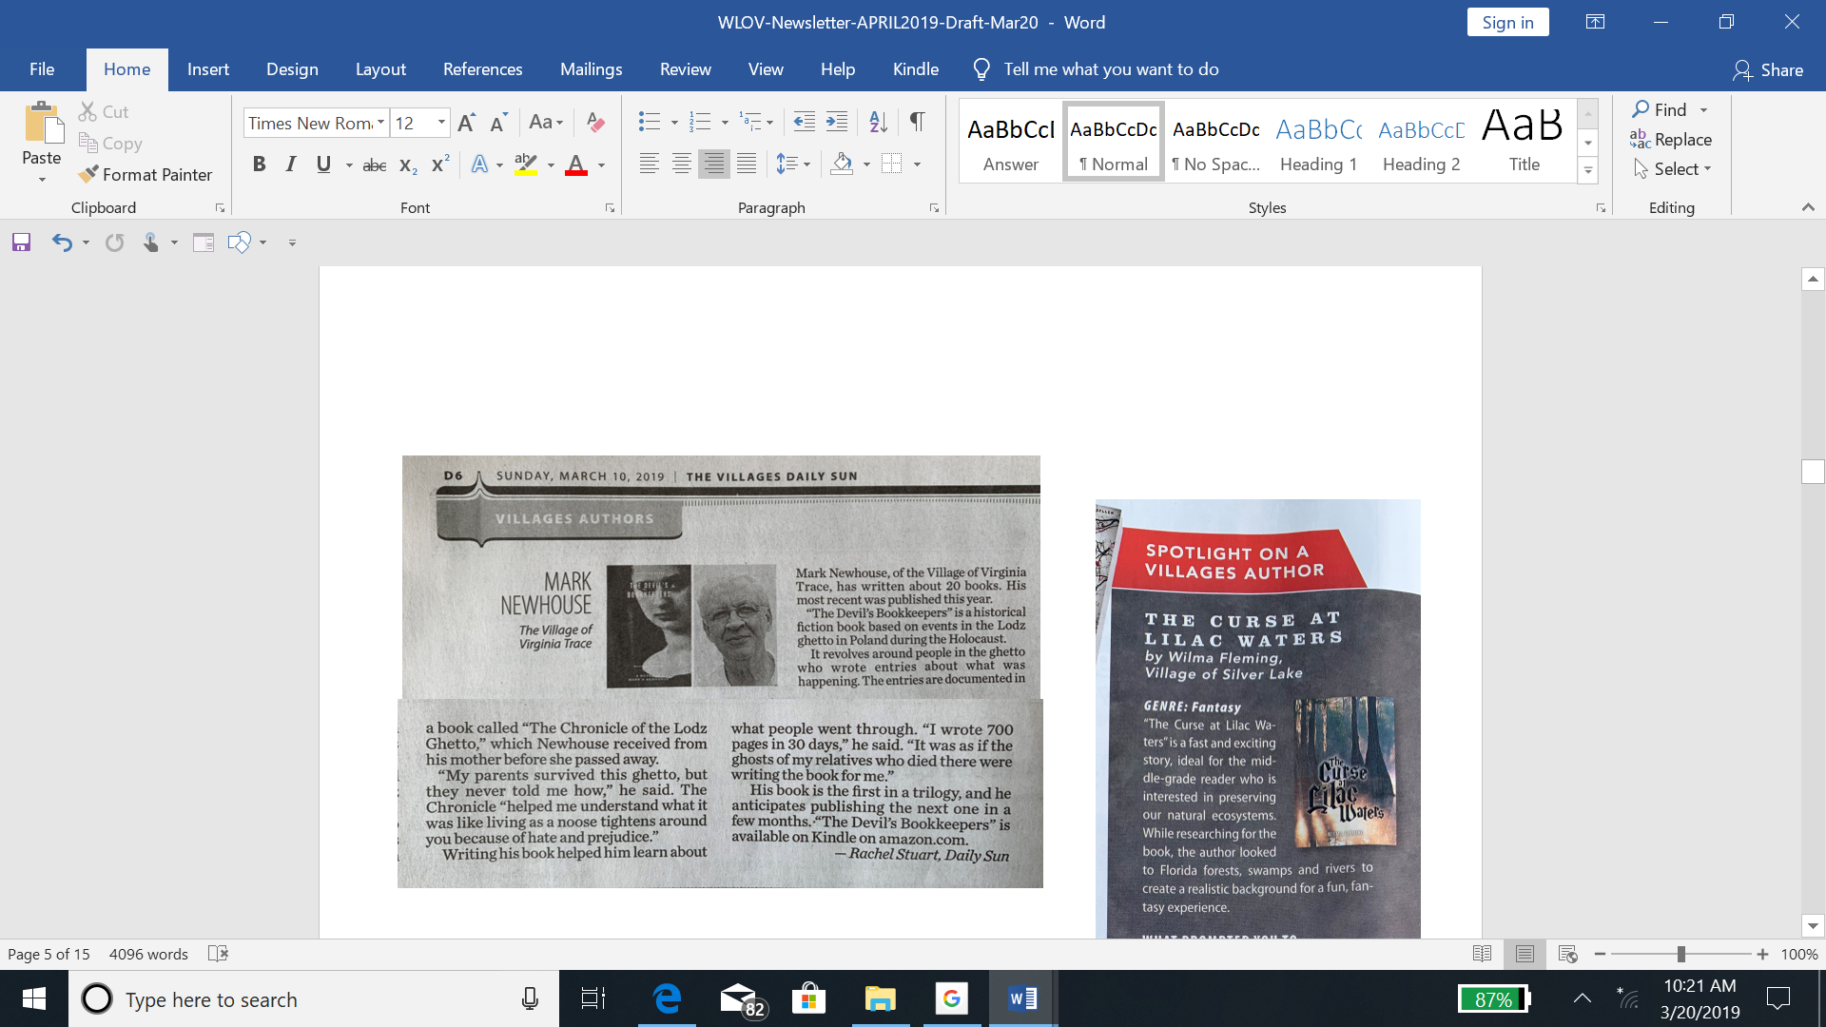

The Villages Magazine, March 2019 🡪

Villages Style Magazine, March 2019 🡪

