How to create a movie using your smart phone
For Iphone users the iMovie App may already be installed on your phone. It is a free app that allows you to edit videos or arrange a collaboration of photos to create a video. You can trim a videos length, record your voice or other sounds, and add music and words to it to completely customize its look.
- Go to your photo album and select the photos/videos. Create a new album and label it.

- Click on iMOVIE. At the top it is labeled: Videos Projects Theater
Click Projects Click the + Create
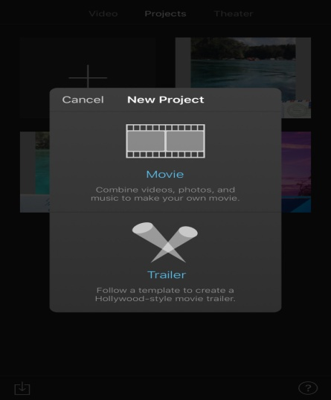

- Click on MOVIE. Your photos will automatically pop up. At the top left corner click on the arrow next to MEDIA a list will then appear. Click on ALBUMS. Click on the album name that you previously made with the photos/videos you selected. Then select the video or photos (in the correct order you want them to appear in the video) then at the bottom click CREATE MOVIE.
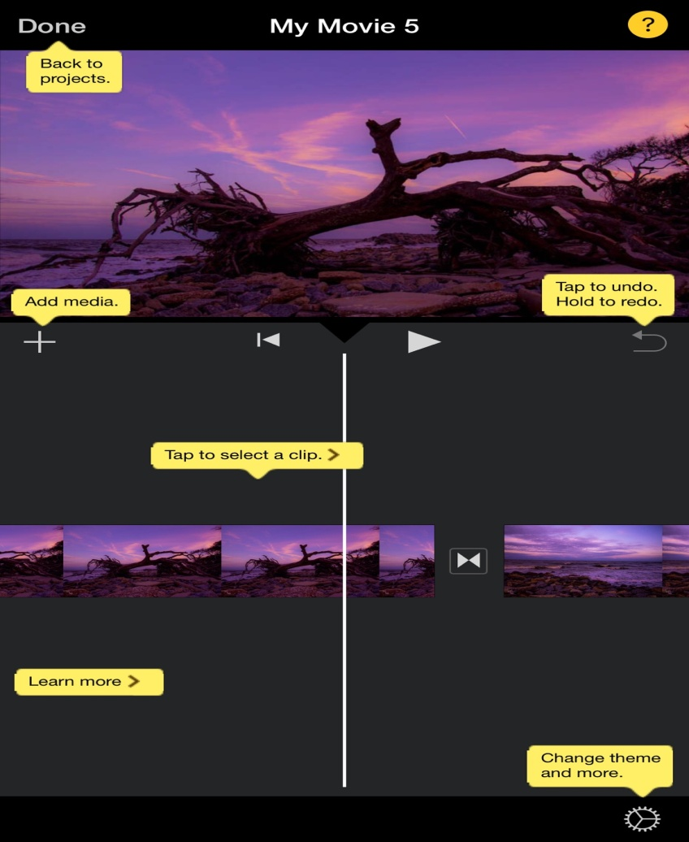
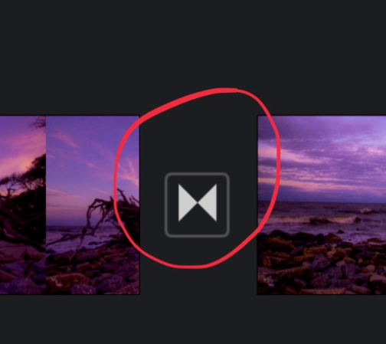 By clicking icon it will direct you to another screen that gives you different options on viewing your photos in the video.
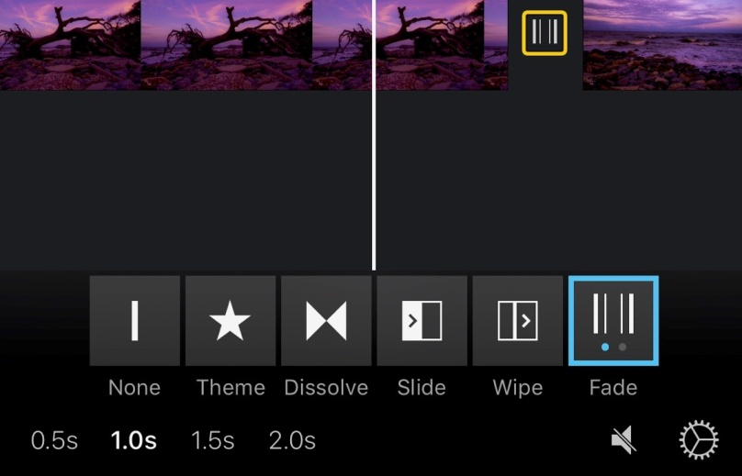 You can decide whether you want a photo to fade in and out before the next photo starts or slides to the next photo. You can also decide how long each photo is shown before it switches to the next one. By clicking the Add Media+ it will bring you to a list of options as shown below. Voiceover allows you to record yourself or other sounds. Audio will allow you to add songs already downloaded on your phone.
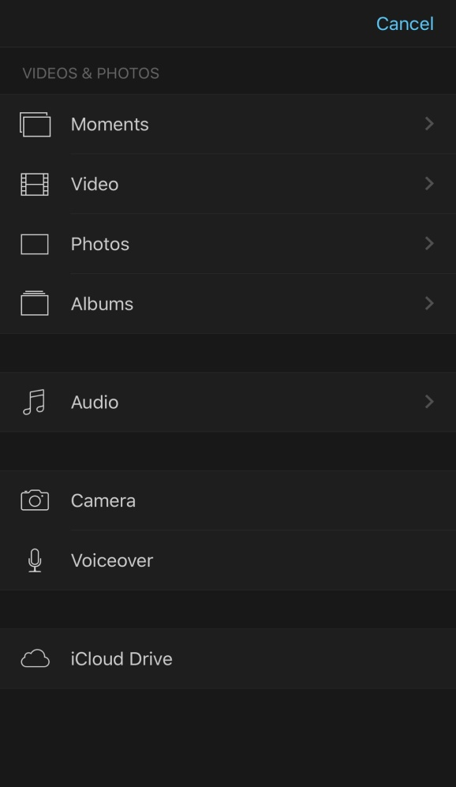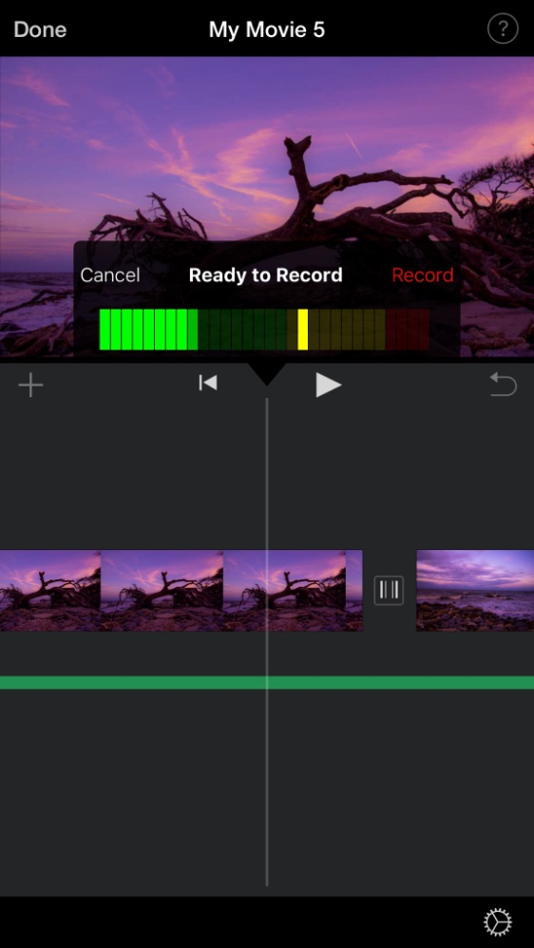
Click the Change theme and more icon will bring you to project settings. It shows you a list of different filters and themed music you can apply. It gives you the option to have your video fade in from a black screen and fade out to a black screen. Just simply click the button to turn that feature on.
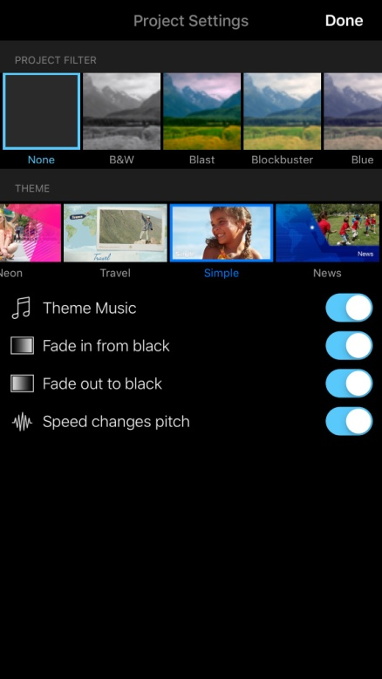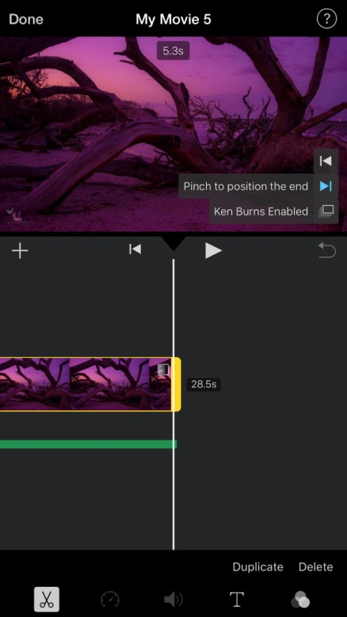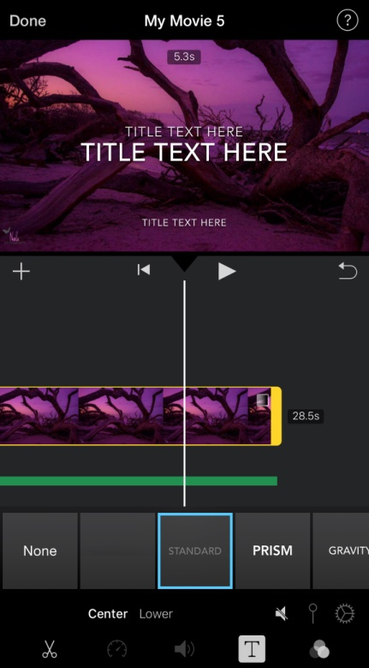
By clicking on the video it will highlight it with a yellow box. You can shorten your video or extend it longer this way.
You can also do the same with the Audio which is the thick green line below it.
With the highlighted yellow box you can add text throughout the video. You can change the font and style and have it fade, expand, pop-up etc. You can view your videos by clicking the play button.
Once you are satisfied with how your video looks click DONE in the top left corner. You can edit your video at any time.
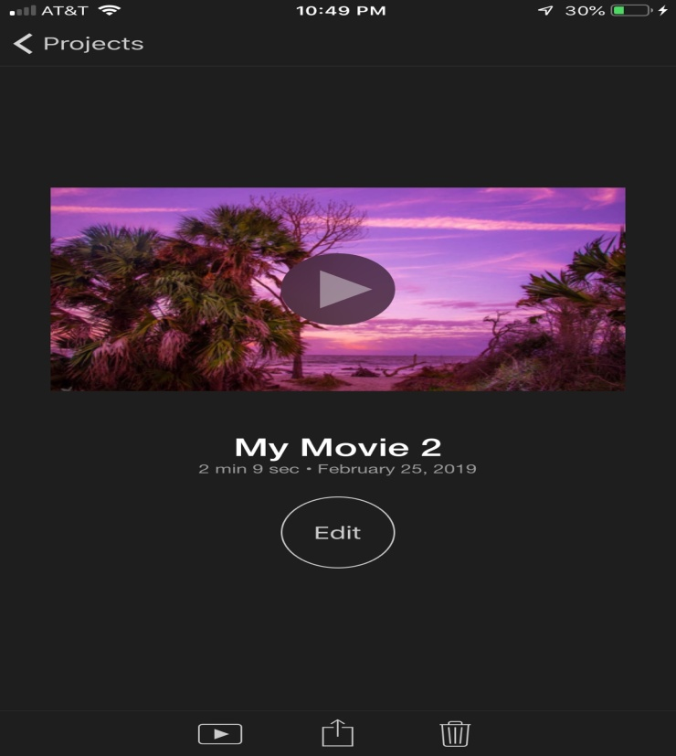 By clicking the bottom middle icon that will give you the option to save your video to your phone, YouTube, Facebook, email etc.

Nicole Hamel
Nicolehamel24@gmail.com
207-274-9676

